

SUPERSTORE SALES ANALYSIS



Contents

**TECHNICAL REPORT** 3

**1. Introduction** 3

**1.1 Introduction** 3

**1.2 Data Description** 3

**1.3 Business Intelligence (BI) KPI Requirements and Questions** 4

**KPI Requirements** 4

**High Level Scope for Analysis & Visuals** 4

**Business Intelligence Questions** 4

**Key User Groups** 5

**Necessity of Information** 5

**2. Data Pre-processing** 6

**2.1 Data Loading** 6

**2.2 Data Cleaning** 9

**Removing Unnecessary Columns** 10

**3. BI Data Modelling via Star Schema** 11

**3.1 Dimension Tables** 12

**4.** **Data Analysis Expressions (DAX)** 27

**4.1 Sales Analysis Dashboard** 28

**4.2 Geographical Pattern Dashboard** 29

4.3 **Discount Dynamics Dashboard** 30

**4.4 Profitability Assessment Dashboard** 31

**4.4 Customer Analysis Dashboard** 31

**5.** **Dashboard** 32

**5.1 Home Page Dashboard** 32

**5.1 Sales Analysis Dashboard** 34

**5.5 Geographical Pattern Dashboard** 39

**5.6 Discount Dynamics Dashboard** 45

**5.6 Profitability Assessment Dashboard** 49

**5.7 Customer Analysis Dashboard** 53

**6. Technical Details (Appendix)** 58

**STAKEHOLDER REPORT** 59

**1. Introduction** 59

**1.1 Executive Summary** 59

**1.2 Data Source** 60

**2. BI Solution Overview** 60

**2.1 BI KPI Requirements and Questions** 60

**KPI Requirements** 60

**High Level Scope for Analysis & Visuals** 61

**Business Intelligence Questions** 61

**Key User Groups** 61

**Necessity of Information** 62

**2.2 Methodology** 62

**Data Collection and Integration:** 62

**Data Modelling and Transformation:** 62

**Selection of Key Performance Indicators (KPIs):** 63

**Why Power-BI?** 63

**3. Key Findings** 64

**3.1 BI Dashboards** 64

**Home Page Dashboard** 64

**Sales Analysis Dashboard** 65

**Geographical Pattern Dashboard** 66

**Discount Dynamics Dashboard** 68

**Profitability Assessment Dashboard** 70

**Customer Analysis Dashboard** 71

**4. Challenges and Limitations** 72

**Challenges** 72

**Limitations** 72

**5. Conclusions and Recommendation** 72

**5.1 Conclusion** 72

**5.2 Recommendation** 73

**5. References** 73

# **TECHNICAL REPORT**

# **1. Introduction**

## **1.1 Introduction**

The emergence of e-commerce has altered how businesses run while providing convenience and accessibility to customers worldwide. Businesses looking to succeed in a competitive marketplace must grasp the intricacies of sales, profitability, and consumer behaviour in the context of e-commerce. Data-driven insights are essential for making well-informed decisions in the ever-changing world of modern business. This dataset provides a thorough overview of sales transactions and reveals a wealth of data that can be used to better understand and optimize different aspects of the sales process. The dataset includes information on products, consumers, locations, and the time-related features of each transaction, among other characteristics.

This study sheds light on these processes by analysing an extensive dataset of retail orders including various product categories, consumer demographics, and geographic locations.

## **1.2 Data Description**

The main source of the dataset used in this study was Kaggle: <https://www.kaggle.com/datasets/ishanshrivastava28/superstore-sales>

Numerous characteristics about specific orders are included in the dataset, including the date of the transaction, the method of shipment, the demographics of the customers, the types of products sold, the amount paid, the discounts offered, and the profits. Our investigation of regional patterns and trends is made possible by the dataset's inclusion of geographic data. We can learn more about various retail operations-related topics by utilising this dataset.

Below is a detailed description of the dataset.

|  |  |  |
| --- | --- | --- |
| Index | Columns | Description |
| 1 | Row ID | An individual number for every row in the dataset |
| 2 | Order ID | A distinct number is assigned to every order |
| 3 | Order Date | The date the order was placed |
| 4 | Ship Date | The date the order was shipped to the customer |
| 5 | Ship Mode | The mode of shipping the order |
| 6 | Customer ID | A distinct number assigned to every customer |
| 7 | Customer Name | The name of the customer |
| 8 | Segment | The customer segment |
| 9 | Country | The country where the order was placed |
| 10 | City | The city where the order was placed |
| 11 | State | The state where the order was placed |
| 12 | Postal Code | The postal code of the location |
| 13 | Region | The region in the country where the order was placed |
| 14 | Product ID | A distinct number assigned to every product |
| 15 | Category | The category where the product falls (e.g., Furniture) |
| 16 | Sub-Category | The sub-category of the product (e.g., chairs) |
| 17 | Product Name | The name of the product |
| 18 | Sales | The total sales generated from the order |
| 19 | Quantity | The number of products ordered |
| 20 | Discount | The discount applied to the order |
| 21 | Profit | The profit generated from the order |

Table 1: Superstore Sales Variables and Descriptions

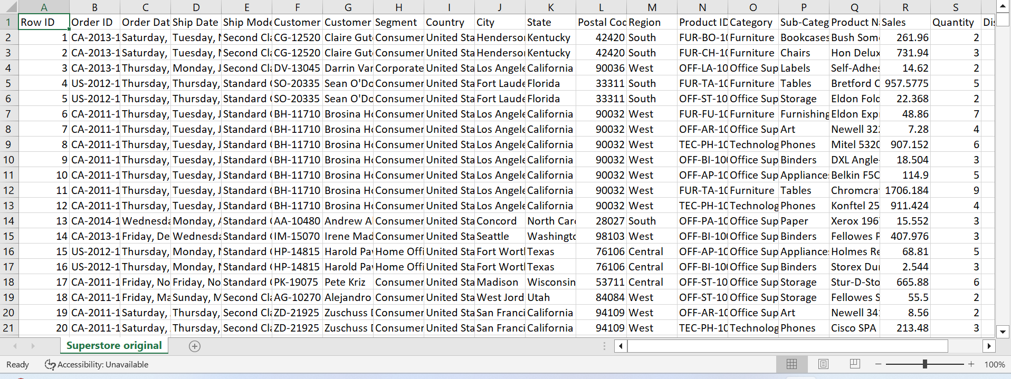

Fig 1: Superstore Sales Dataset in Excel

## **1.3 Business Intelligence (BI) KPI Requirements and Questions**

### **KPI Requirements**

Key Performance Indicators are essential measurements used to assess how well corporate objectives are being met. KPIs are intended to provide actionable insights into sales dynamics, geographic trends, the efficacy of discounts, profitability, and consumer behaviour within the framework of our business intelligence architecture. Metrics like Discounted Sales, Average Profitability by Region, Monthly Sales Growth Rate, and Total Sales by Ship Method are examples of these indicators. Sales managers, the marketing team, and executives have distinct demands, and KPIs are designed to address those needs by giving them quantitative measurements to evaluate performance, make data-driven decisions, and optimise their own plans.

### **High Level Scope for Analysis & Visuals**

The high-level scope highlights a thorough approach to data analysis by outlining the depth and breadth of our analytics and graphics. Analytics will examine complex patterns in sales data to provide a more detailed picture of consumer behaviour, regional variations, and the effects of discounting tactics. A variety of graphs and charts will be included in the visuals, such as bar charts for profitability analysis, spider charts for discount efficacy, maps for regional insights, and line charts for sales trends. This breadth makes sure that our BI system offers a comprehensive picture in addition to specific responses, enabling a thorough understanding of the business environment to support well-informed decision-making at all organisational levels.

### **Business Intelligence Questions**

The business intelligence questions that this analysis aims to answer are:

1. Sales Analysis: Is there a seasonal pattern or trend in the volume of sales?
2. Geographical Patterns: Is there any geographic pattern that influences profitability & Sales?
3. Discount Strategies: What effects does discount have on sales, quantity sold, customer segment, profitability?
4. Profitability Assessment: Which product or product category makes the biggest contribution to total profitability?
5. Customer Analysis: What insights may be obtained by examining the overall sales generated based on the customer's choice of ship method, and how do individual customer preferences affect both sales and profitability?

### **Key User Groups**

1. Sales Managers:

Sales analysis is a valuable tool for sales managers to spot trends, pinpoint high-performing goods, and enhance their marketing approaches. Discount strategies are essential for them to comprehend the efficacy of discounts, adjust pricing, and strategically motivate sales personnel. Furthermore, in order to maintain long-term business growth and profitability, profitability assessment helps sales managers concentrate their efforts on high-margin items and customer segments.

1. Marketing Team:

The Marketing Team's interest on Geographical Patterns enables them to customise campaigns according to local tastes, guaranteeing focused and culturally appropriate advertising. The team may optimise marketing efforts for maximum impact by using sales analysis, which offers vital information into client segments and product popularity. Understanding the efficacy of discounts is another aspect of their focus on discount strategies, which helps the team create promotions that appeal to consumers and increase sales.

1. Executives:

Executives use the Profitability Assessment to set resource priorities, concentrating on critical business sectors and high-margin items. Geographical patterns support the identification of worldwide market trends, the direction of expansion plans, and the alignment of the organisation with a variety of market circumstances. Moreover, customer analysis gives executives insights into personal preferences, enabling customised plans and cultivating enduring customer relationships that are essential for long-term company success.

### **Necessity of Information**

1. Sales Managers:

Sales managers need real-time insights to quickly adjust their sales strategy in response to changing market conditions. Having access to real-time data enables them to take rapid, well-informed decisions, which guarantees flexibility in handling obstacles and seizing new opportunities.

1. Marketing Team:

The Marketing Team needs data in order to develop campaigns that appeal to its target audiences. With real-time analytics, the team can dynamically modify marketing strategies to keep campaigns relevant and successful in a market that is changing quickly.

1. Executives:

Comprehensive reports provide executives with a comprehensive understanding of the functioning of their organisations. Executives may recognise broad patterns with the help of this integrated picture, which enables them to make strategic decisions that support the organization's long-term objectives. Consolidated reports also make it easier for leadership teams to collaborate and communicate effectively.

# **2. Data Pre-processing**

## **2.1 Data Loading**

The first process in any analysis is to import the dataset into Microsoft Power-BI. This is done firstly by starting the Power-BI app.

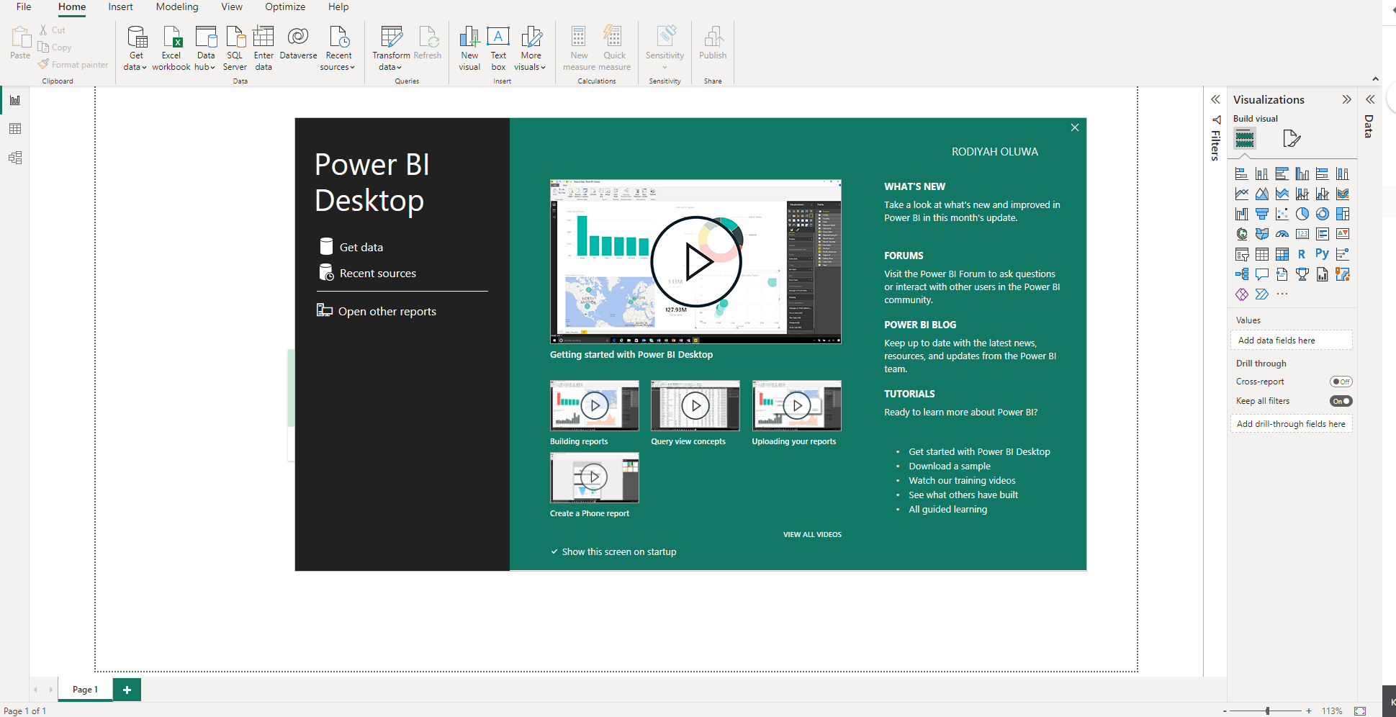Fig 2: Starting Microsoft Power-BI

The next step is to click on the “Get Data” or on the “Get Data” dropdown in the home ribbon. The “Get Data” and “Get Data” drop-downs show various ways of importing a dataset into Microsoft Power-BI, depending on what type of dataset you want to work on (e.g., CSV, Excel etc.). The dataset is a CSV file, so it was imported into Power BI by clicking on Text/CSV.

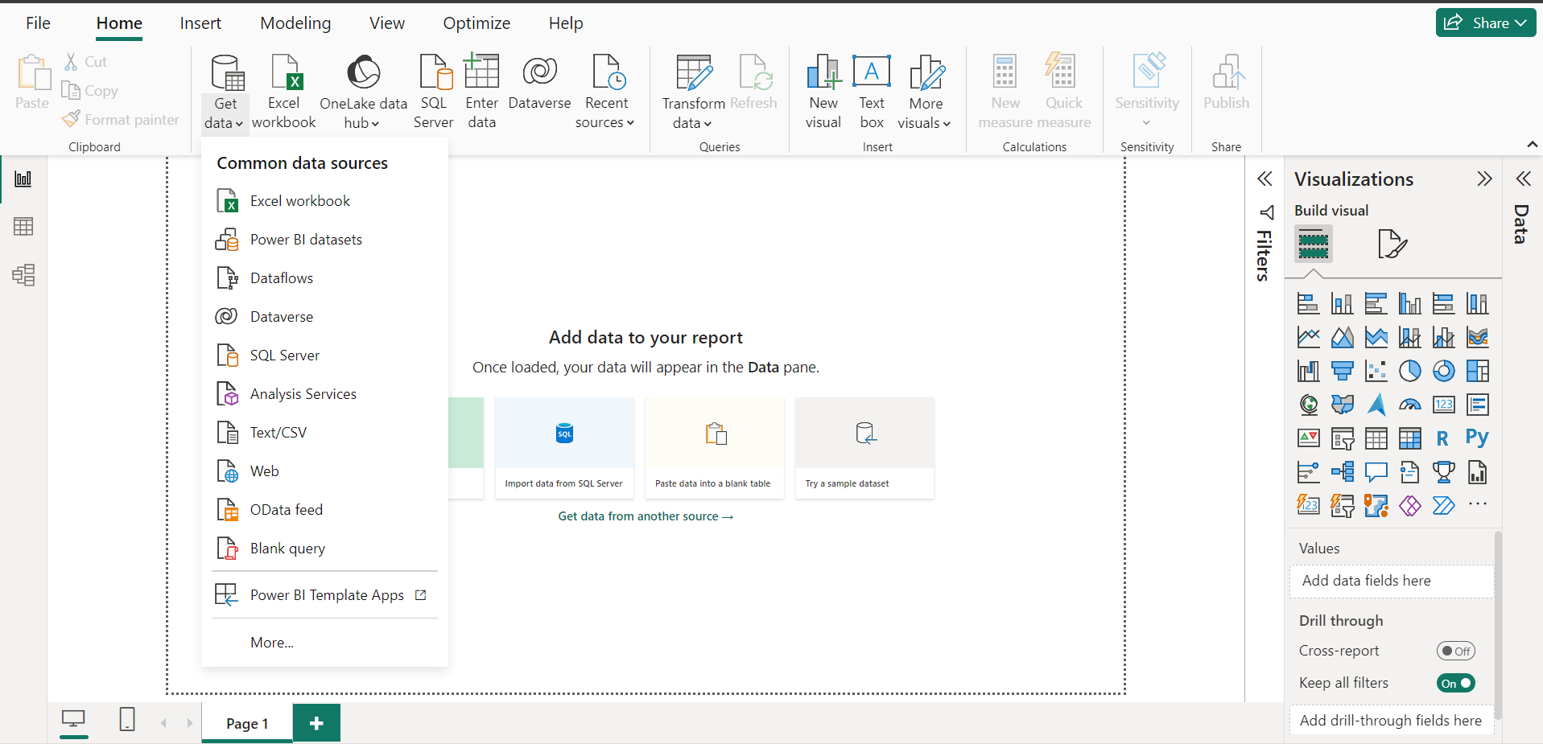

Fig 3: “Get Data” dropdown button showing different ways of importing a file into Power-BI

Once the text/CSV was selected, the computer files were opened and the dataset was selected. The process of importing the Superstore Sales dataset into Power-BI was completed.

A Dialog Box then comes up showing the first 20 rows in the dataset (Based on the first 200 rows) & options to either load, transform or cancel the data.

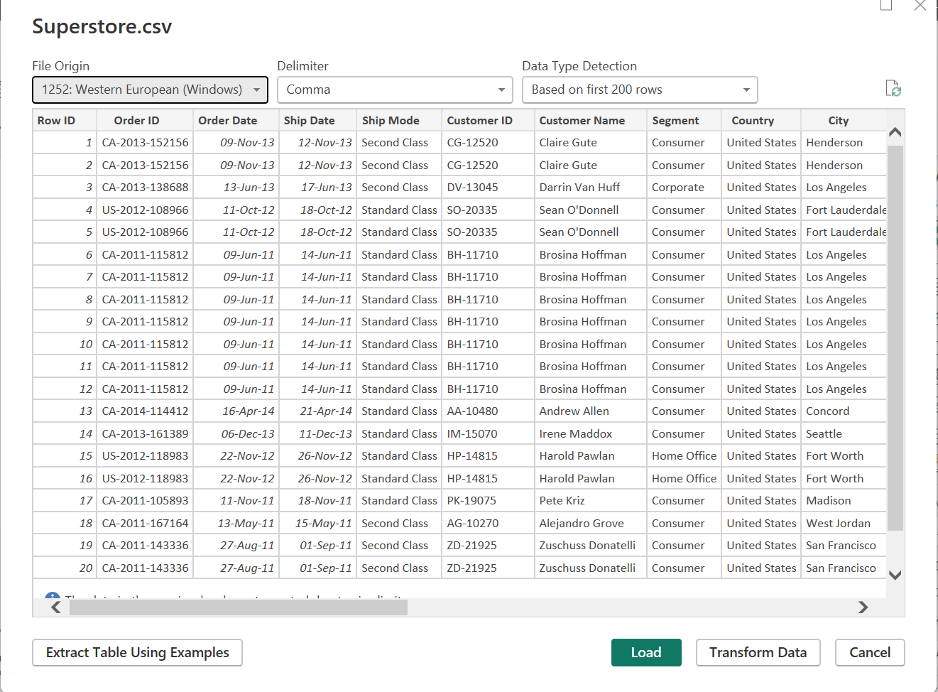

Fig 4: Dialog Box showing the first 20 rows in the dataset & whether to load, transform or cancel the dataset.

The load option was selected, and the Superstore Sales data table was successfully loaded into Power-BI.

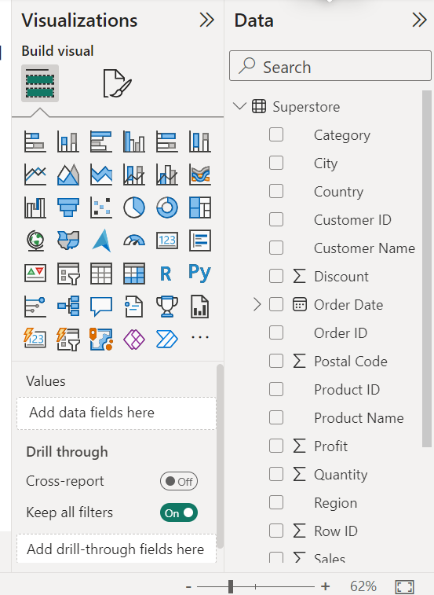

Fig 5: Superstore Dataset successfully loaded into Power-BI

## **2.2 Data Cleaning**

Now that the dataset has been successfully loaded into Power-BI, the next step is to begin data pre-processing and Cleaning. The Data Pre-processing and Cleaning would be done in the Power Query Editor. This can be done by selecting the “Transform Data” in the home ribbon.

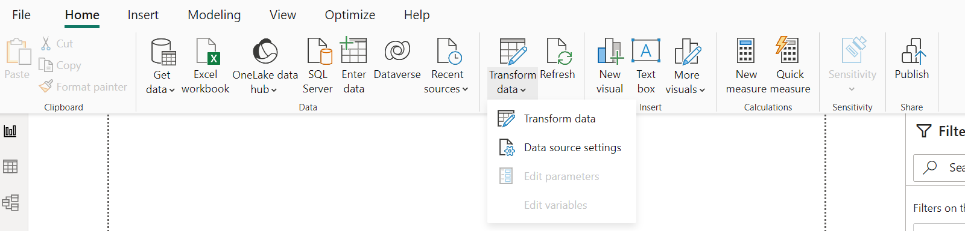

Fig 6: Transform Data Button

After selecting the Transform data button, the Power Query Editor comes up. The main tool for preparing data is the Power Query Editor, which allows one to evaluate data and choose transformations from the user interface (UI) while connecting to a variety of data sources and applying hundreds of different data transformations.

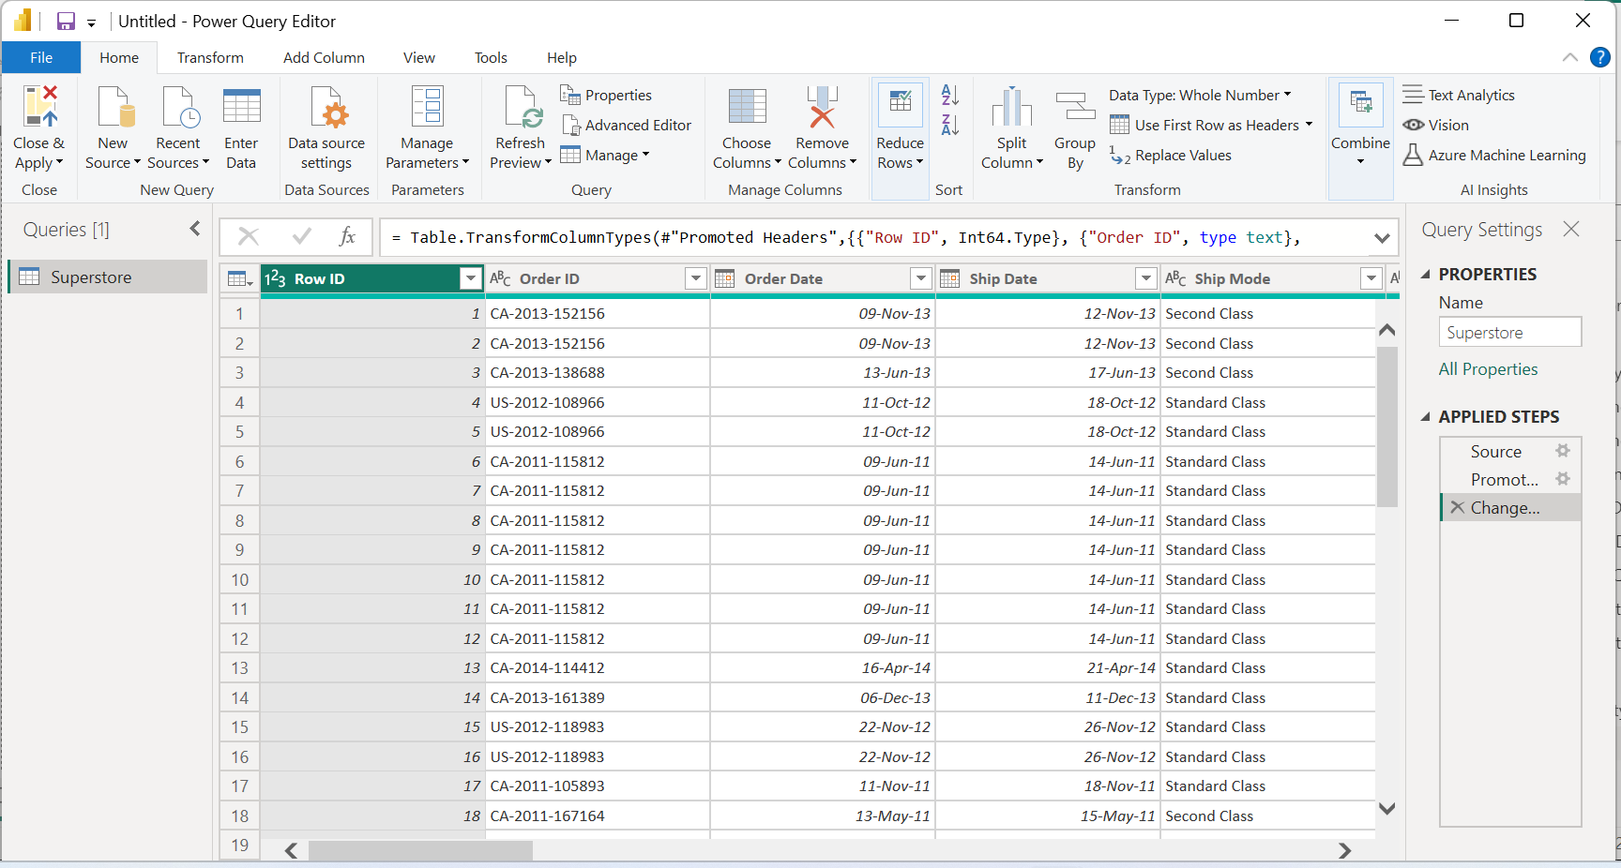

Fig 7: Power Query Editor

Once the query editor is opened, the view option is selected from the ribbon to show the quality of each column. The Column quality shows the characteristics of each column, it shows the valid, error & empty percentages for each column.

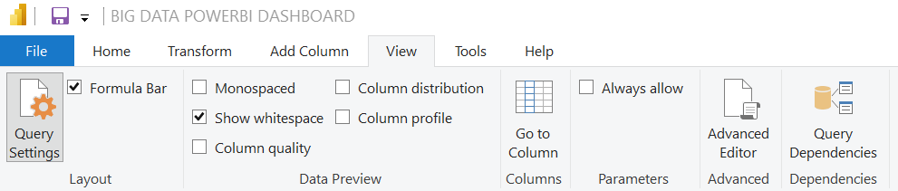

Fig 8: Power Query Editor/ View Column Quality

After selecting the column quality button, the quality of each column in the dataset was displayed. Every Column in the dataset had a validity of 100% showing that there are no errors as well as empty cells within the dataset.

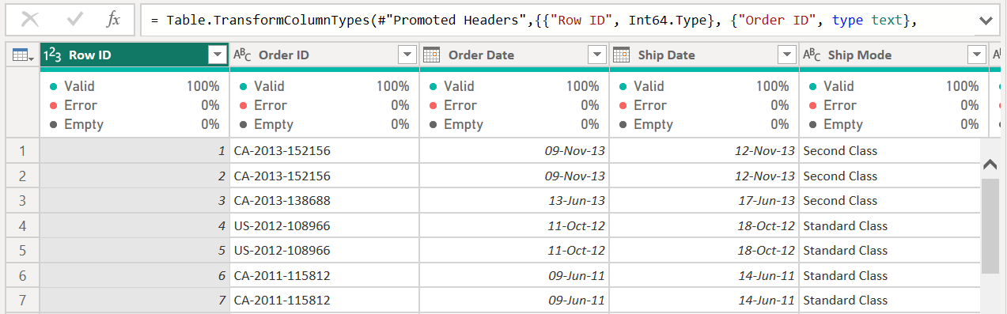

Fig 9: Power Query Editor/ Column Quality Result

### **Removing Unnecessary Columns**

The Row ID column would be removed from the dataset as it’s of no use in this analysis.

***M Language to remove unnecessary columns:***

***= Table.RemoveColumns(#"Changed Type",{"Row ID"})***

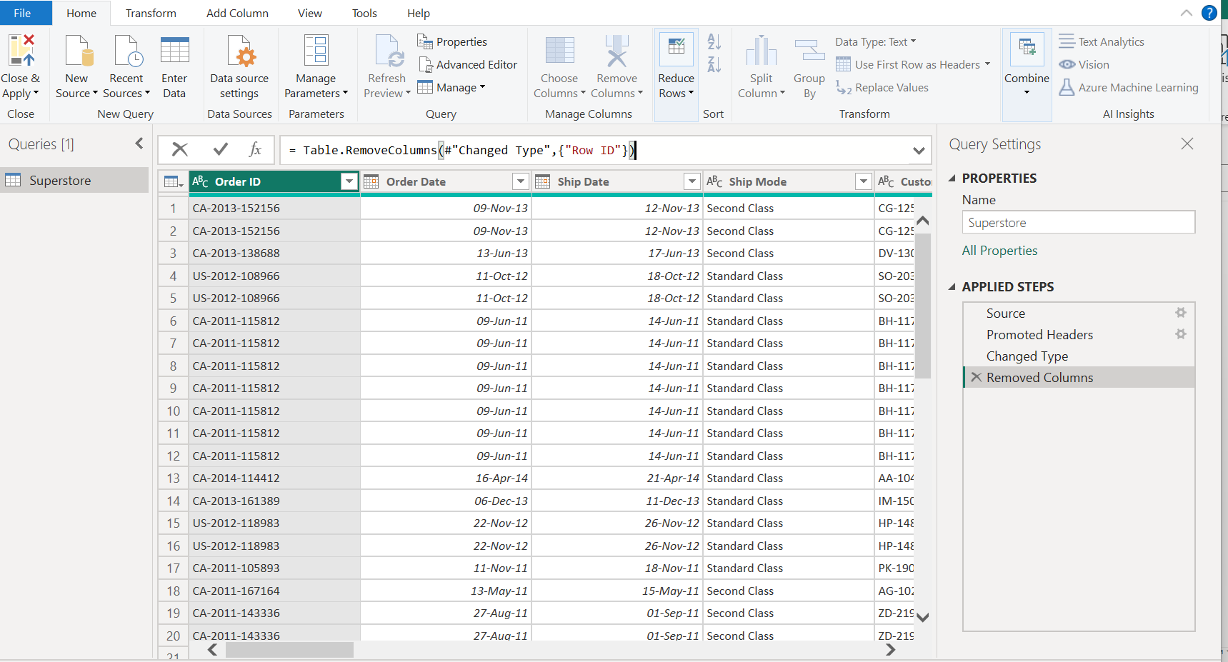

Fig 10: Removing Unnecessary Column

# **3. BI Data Modelling via Star Schema**

The data-modelling schema that would be used in this analysis is Star Schema. One kind of database structure that's frequently utilized in data warehousing is the star schema. It is comprised of one or more-dimension tables linked to a core fact table. The fact table sits in the middle of the arrangement, with dimension tables encircling it like a star, giving rise to the name of the schema.

Before data cleaning, the figure below shows us what the data model looks like.

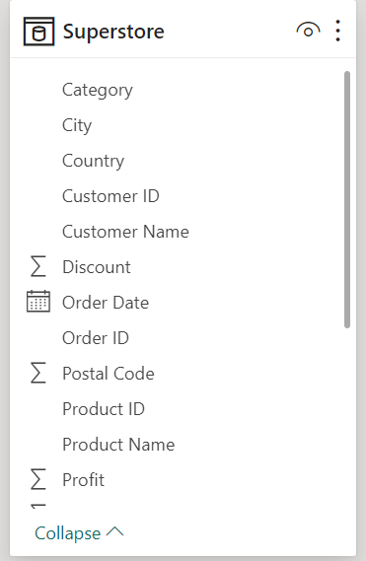

Fig 11: Data Model before Cleaning

The data model only shows a fact table, so the next step is to create various dimension tables (smaller tables). Driven by the need to simplify, organize, and optimize data, dimension tables are a basic practice in database architecture. Dimension tables create a more resilient and controllable data architecture by minimizing redundancy, simplifying complex processes, facilitating in-depth analysis, and improving the visualisation process.

## **3.1 Dimension Tables**

To create dimension tables, I’d be duplicating the fact table(superstore) for every dimension table I want to create.

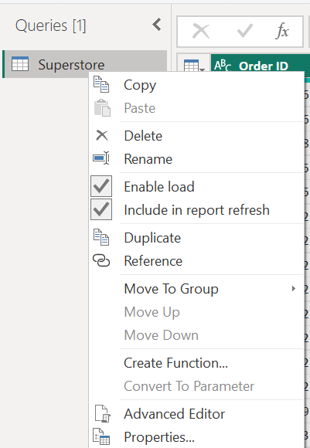

Fig 12: Duplicating fact table to create various dimension tables.

The Customer dimension table consists of the Customer ID, Customer Name and segment. To create this table, I would be duplicating the superstore table & renaming it “Customer Dimension”.

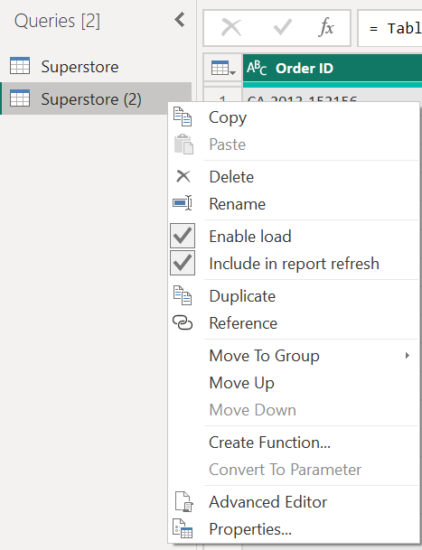

Fig 13: Creating Customer Dimension Table by creating duplicate & renaming.

After creating & renaming the table the next thing is to click on the ctrl key & select all columns belonging to the Customer Dimension Table. Once all the columns have been selected, I right clicked on the header of one of the selected columns & removed other columns not belonging to the Customer Dimension Table.

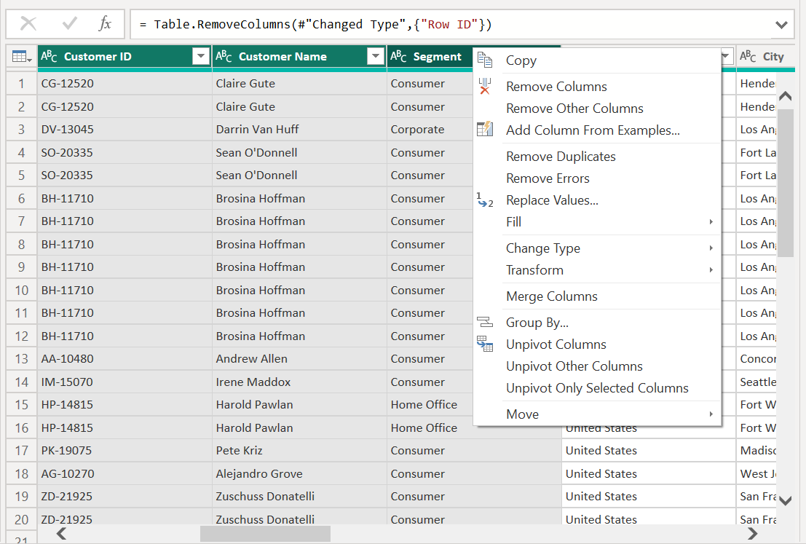

Fig 14: Selecting columns that belong to the table & removing other columns

Another way to do this is by using M Language. The M Language for selecting these columns in the order dimension is:

*= Table.SelectColumns(#"Removed Columns",{"Customer ID", "Customer Name", "Segment"})*

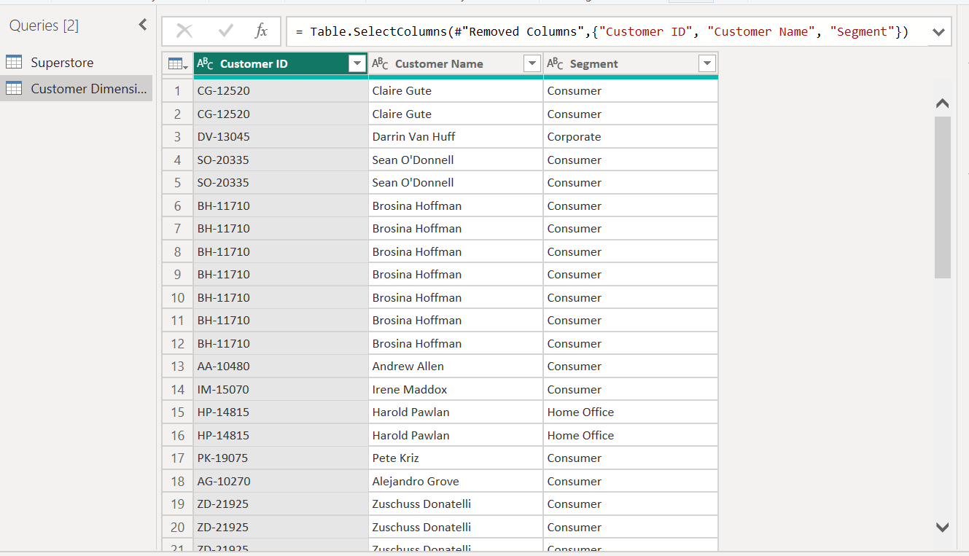

Fig 15: Customer Dimension Table Created

The same process was used to create 5 more tables: Product Dimension, Location Dimension, Ship Date Dimension, and Order Date Dimension. The Superstore table which is the fact table was also renamed as Sales Fact.

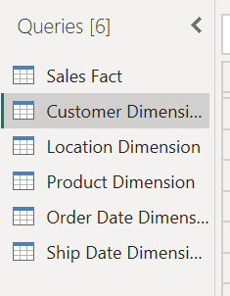

Fig 16: Dimension Tables Created

The next thing to do is to check for duplicates in each dimension table & remove duplicates from tables. This is also done in the query editor.

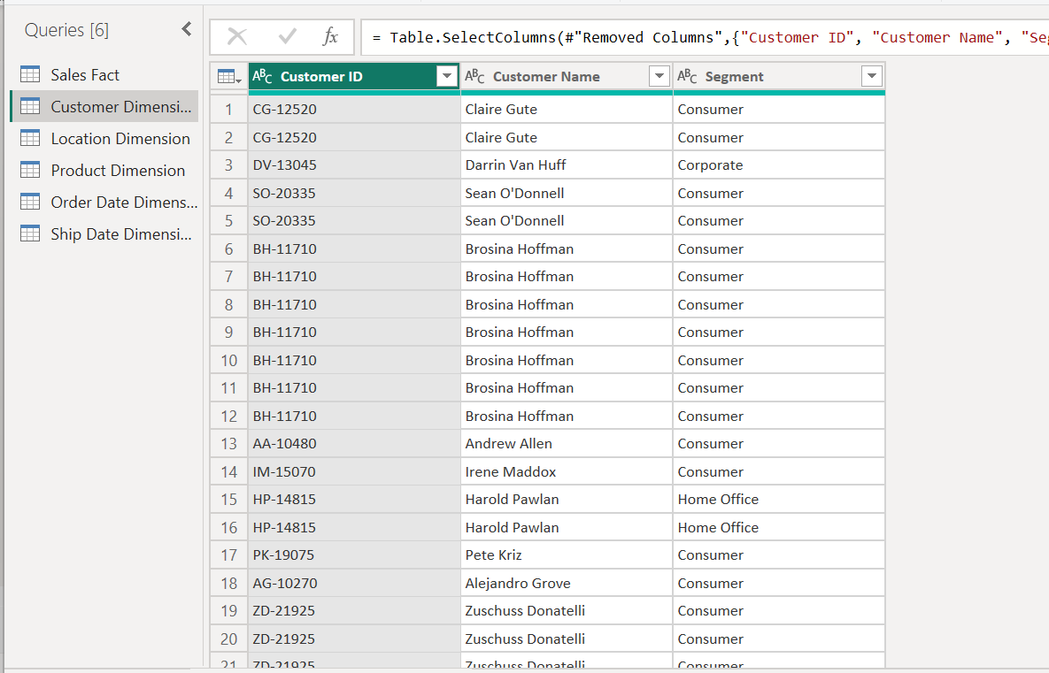

Fig 17: Customer Dimension table showing duplicates.

The Customer dimension table shows that some customers are duplicated i.e., they have the same ID, Names & Segments. So, the next step is to remove duplicates from the table. To do this, I would right-click on the Customer ID column and select “remove duplicates”.

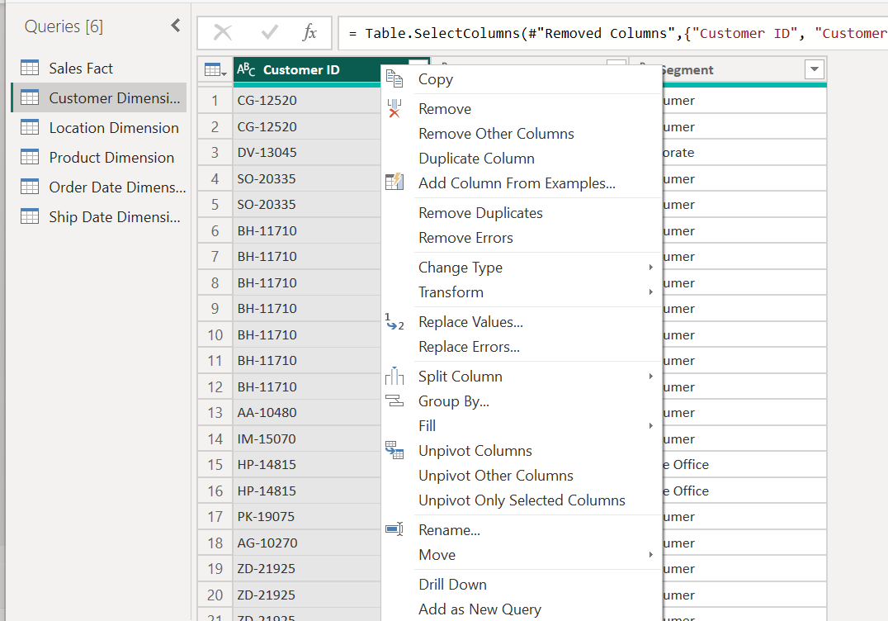

Fig 18: Removing duplicates from the customer dimension table.

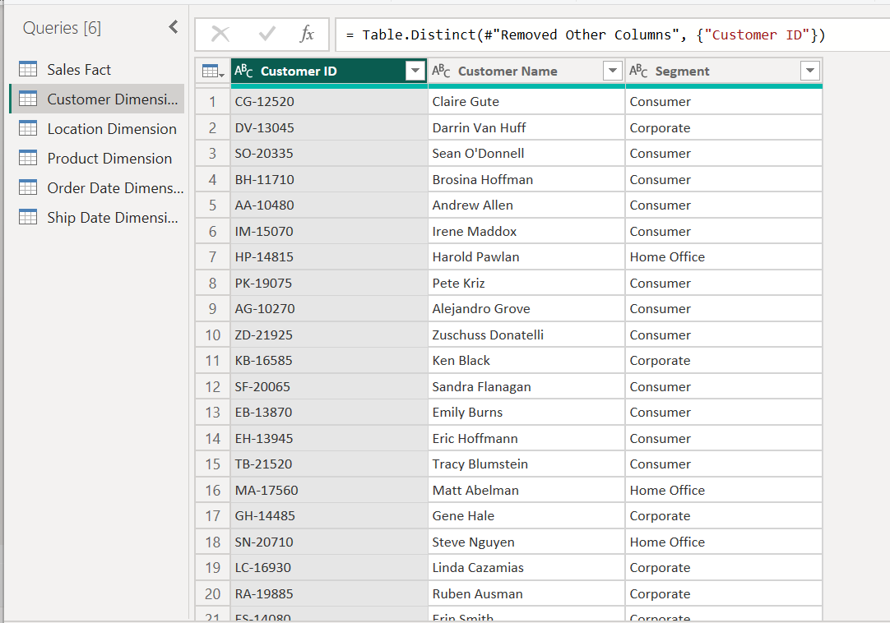

Fig 19: Customer Dimension Table after duplicates were removed.

This same step would be performed on the remaining dimension tables. The figures below would show the tables before & after duplicates.

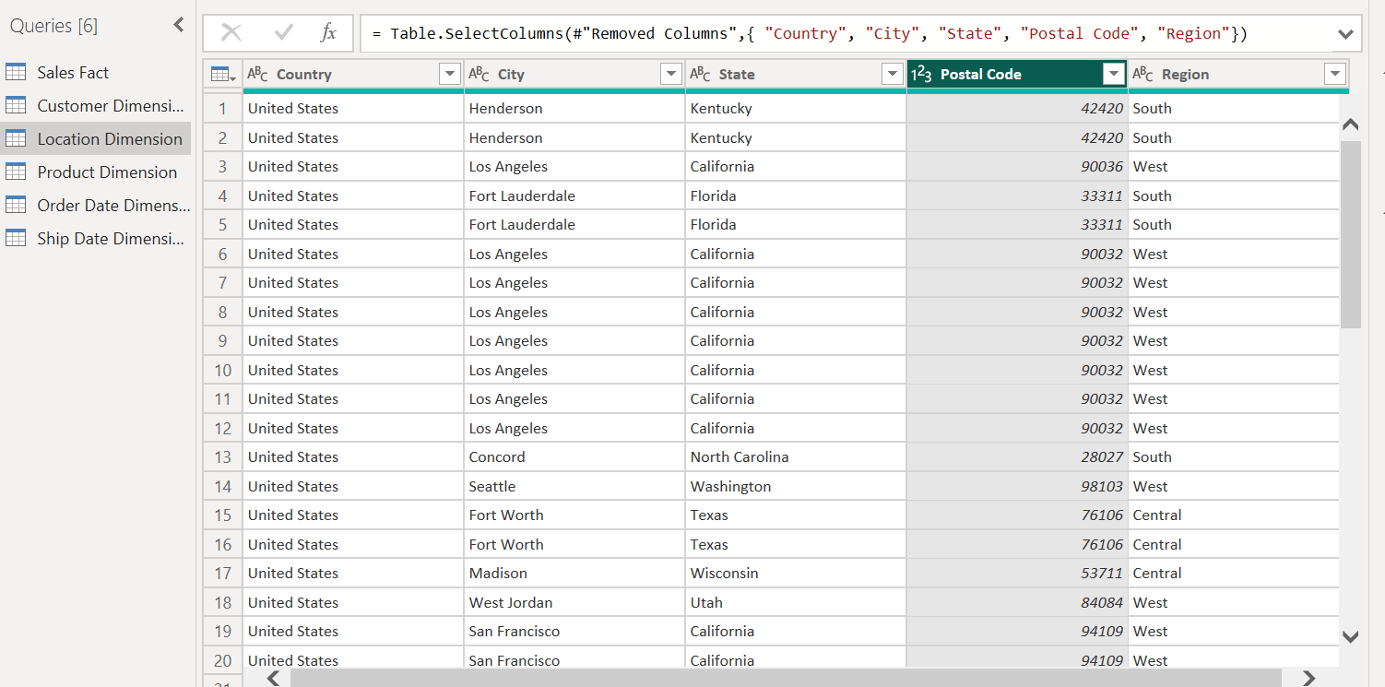

Fig 20: Location Dimension Table before duplicates were removed.

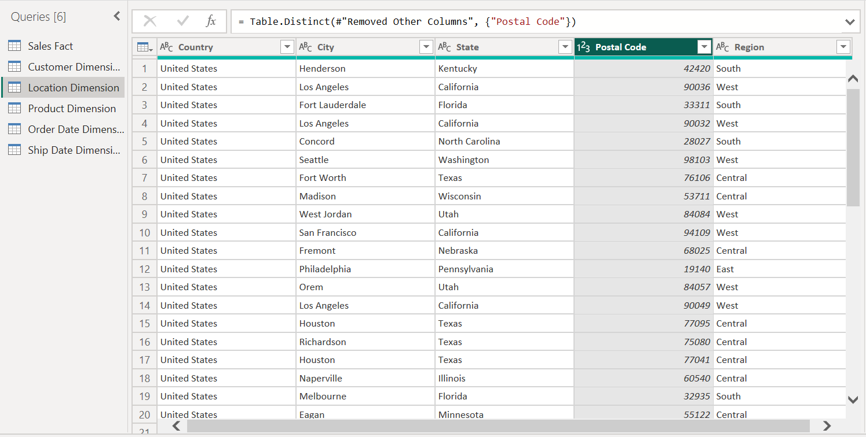

Fig 21: Location Dimension Table after duplicates were removed.

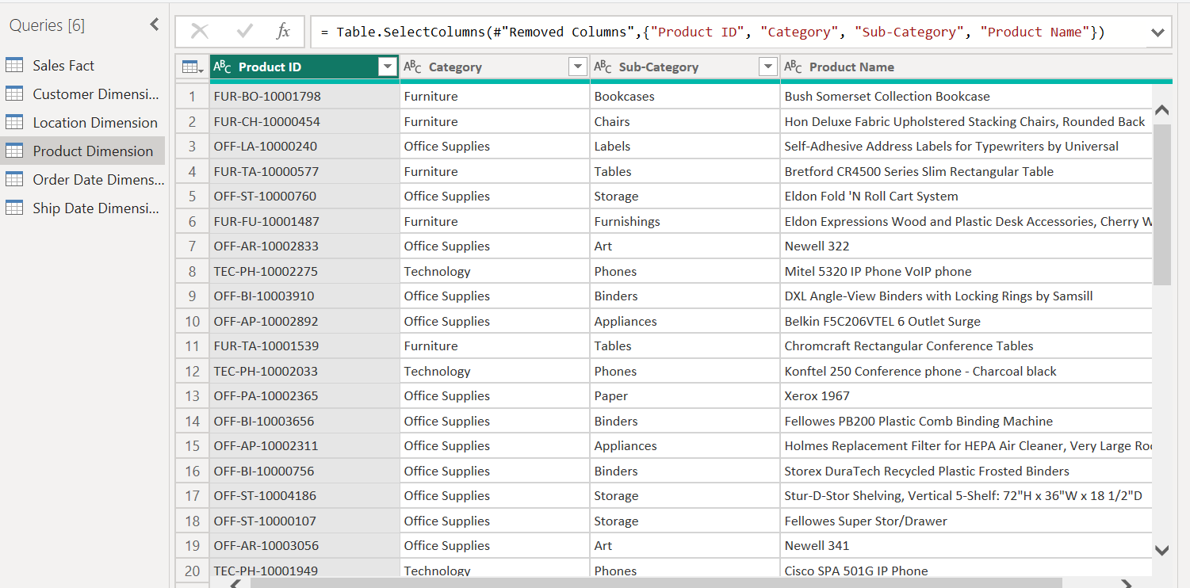

Fig 22: Product Dimension Table before duplicates were removed.

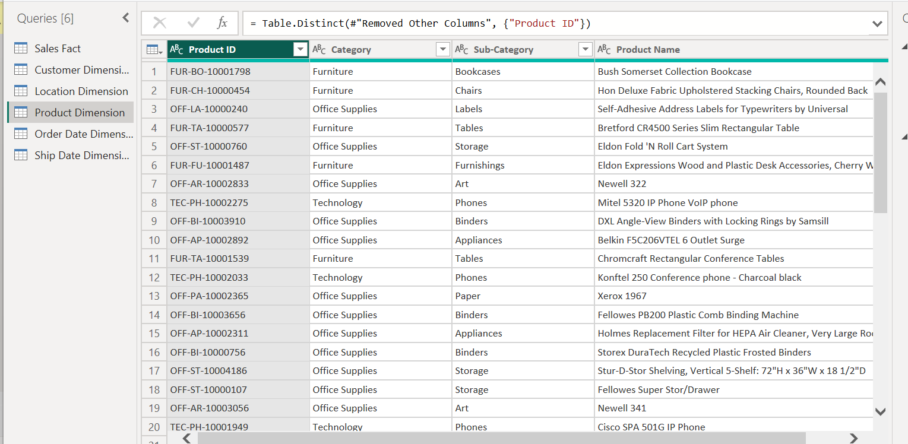

Fig 23: Product Dimension Table after duplicates were removed.

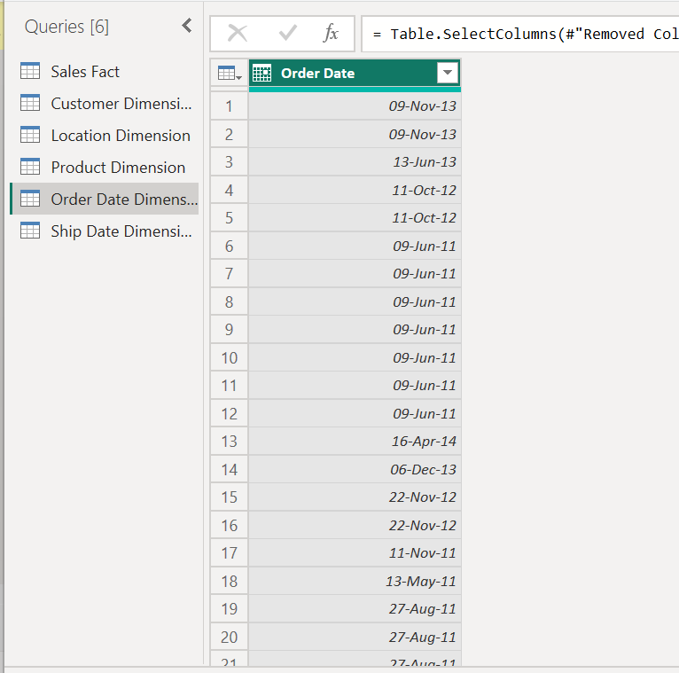

Fig 24: Order Date Dimension Table before duplicates were removed.

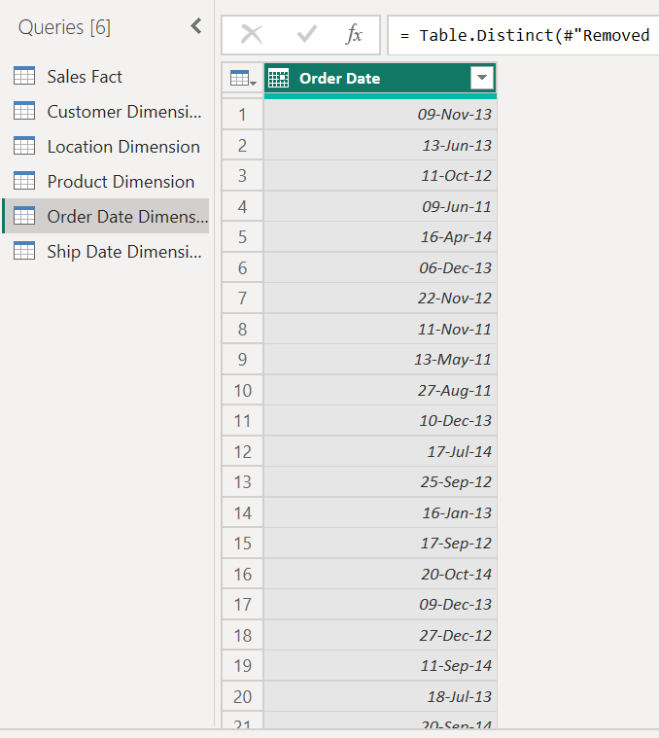

Fig 25: Order Date Dimension Table after duplicates were removed.

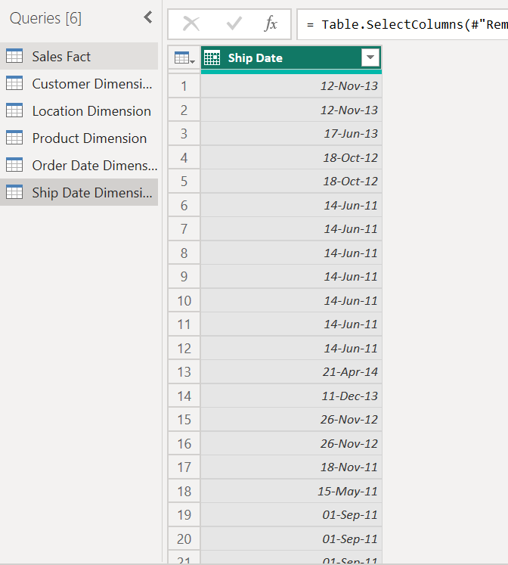

Fig 26: Ship Date Dimension Table before duplicates were removed.

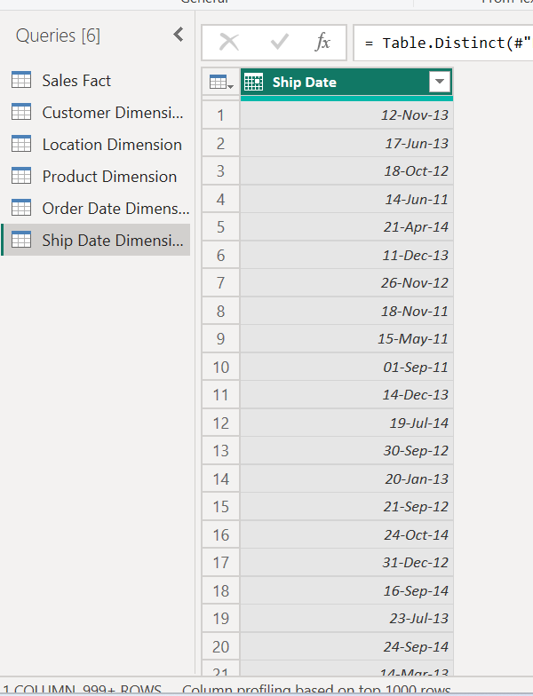

Fig 27: Ship Date Dimension Table after duplicates were removed.

After removing duplicates, the next step is to ensure that each dimension table has a unique identifier that can be used to establish relationships between the dimension tables & the fact table.

The main key also referred to as a unique identifier for each row, is created by adding an ID column to every table. In a relational database, this primary key is essential for creating relationships between tables. By using foreign key relationships, it guarantees that every entry may be uniquely identified and connected to relevant data in other tables. Primary and foreign key usage ensures accuracy, avoids duplication, and supports data integrity. It also offers a defined and structured method for joining and analysing data across various tables, which facilitates effective searching and data retrieval. The technique, which makes for strong data management and analysis in programs like Power BI, is essential to relational database architecture, even though it could appear like an extra column.

While looking through each table it was noticed that the Customer Dimension table & Product Dimension Table had unique identifiers which are the Customer ID & Product ID respectively. Order Date Dimension & Ship Date Dimension Tables don’t need unique identifiers as the Order Date & Ship Date would be used as the primary keys. Postal Code in the Location Dimension table would be used as the unique identifier.

**Expanding Date Columns in Ship & Order Date Dimension Tables**

The Date Columns in both the order and ship date dimension tables would be expanded into day, month, quarter and year. The reason for this expansion is to enable easier visualisation.

I will be starting with the Order Date Dimension table. To divide the date into day, month, quarter and year, I would be doing that in the “Advanced Editor”. The Advanced Editor would be selected in the home tab.

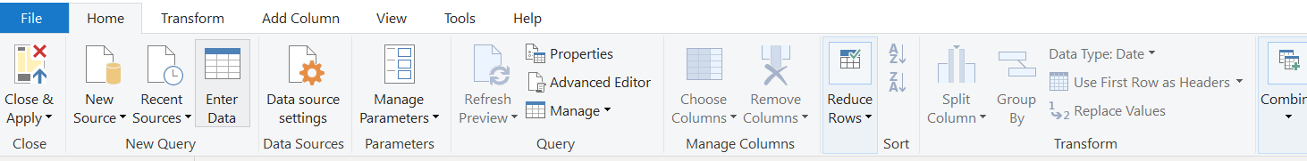

Fig 28: Selecting the advanced editor.

After Selecting the advanced editor, the advanced editor box comes up showing every step that’s been carried out in the order date dimension table. To divide the table, I’d be adding more codes in the advanced editor. The codes are:

#"Added Day" = Table.AddColumn(#"Removed Duplicates", "Day", each Date.Day([Order Date])),

#"Added Month" = Table.AddColumn(#"Added Day", "Month", each Date.ToText([Order Date], "MMMM")),

#"Added Quarter" = Table.AddColumn(#"Added Month", "Quarter", each Date.QuarterOfYear([Order Date])),

#"Added Year" = Table.AddColumn(#"Added Quarter", "Year", each Date.Year([Order Date]))

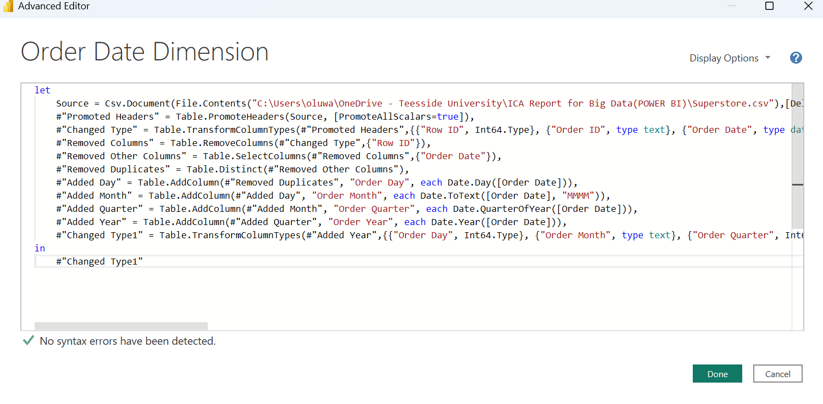

Fig 29: Advanced Editor

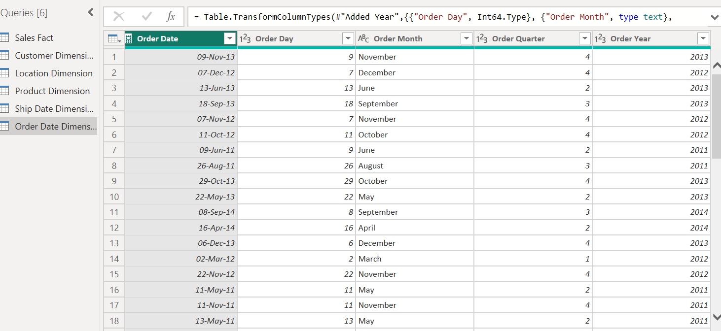

Fig 30: Order Date Dimension Table after expansion

This same process would be performed in the ship date dimension table.

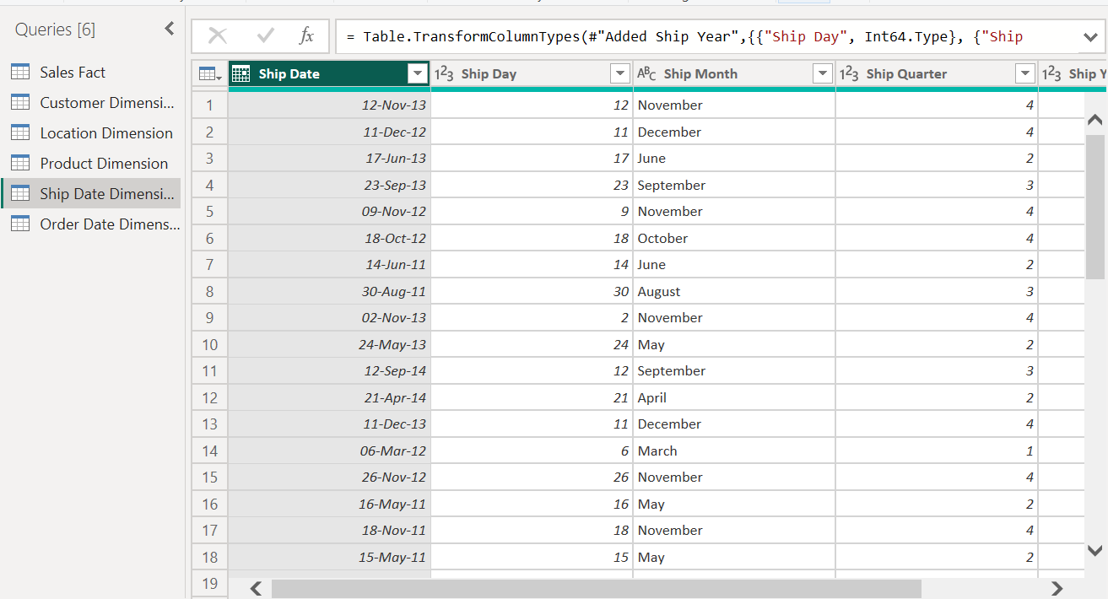

Fig 31: Ship Date Dimension Table after expansion.

**Removing unnecessary columns from the Fact Table**

The fact table, which is the Sales Fact table, includes the unique identifiers from all dimension tables, so, the next thing is to remove all unnecessary columns.

To do this, the ctrl key would be pressed while selecting all necessary columns, after selecting all columns, I would right-click on any of the selected columns & select remove other columns.

The columns to be included in the fact table are Order ID, Order Date, Ship Date, Customer ID, Product ID, Ship Mode, Sales, Postal Code, Quantity, Discount, and Profit.

Another way to do this is by using M Language. The M Language for selecting all needed columns in the fact table is:

***= Table.SelectColumns(#"Renamed Columns",{"Order ID", "Customer ID", "Product ID", "Sales", "Quantity", "Discount", "Profit", "Postal Code", "Order Date", "Ship Date","Ship Mode"})***

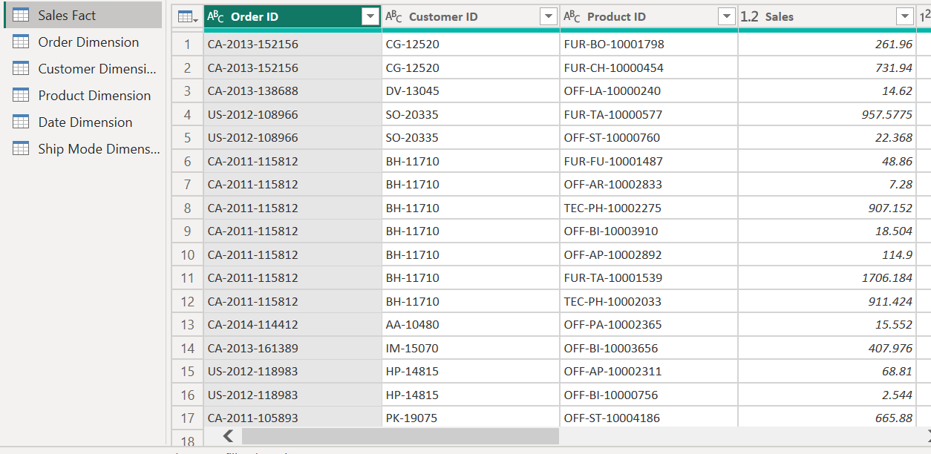

Fig 32: Sales Fact Table.

After Creating dimension tables and doing all the necessary cleaning on the dataset, the next thing is to close the query editor by clicking on close & apply in the ribbon.

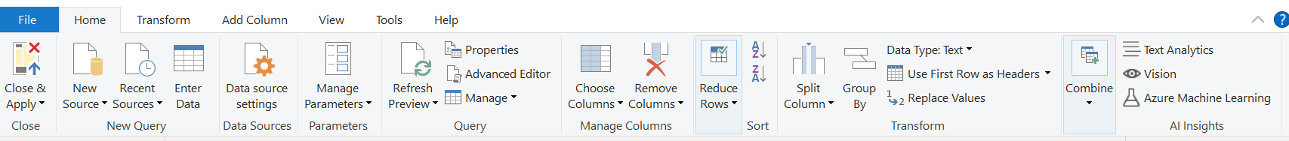

Fig 33: Close & Apply in Query Editor.

The data model now comprises of 6 tables which include a fact table which is the “Sales Fact” and 5-dimension tables which are the Customer Dimension, Location Dimension, Product Dimension, Order Date, and Ship Date.

The Sales fact table consists of the primary key connecting the dimension tables to the fact table as well as the sales, profit, discount and other features that contribute to sales. The Consumer dimension table includes information like the customer’s ID, name and segment. The location Dimension table includes information regarding the customer’s location, country, state, city, postal code etc. The product Dimension table includes information relating to the products such as the product ID, product category, sub-category as well as product name. The order date dimension includes everything that has to do with the date the order was placed, while the ship date dimension includes everything regarding when the other was shipped.

After Creating dimension tables & removing unnecessary columns &duplicates, Fig 39 below shows what the model view looks like

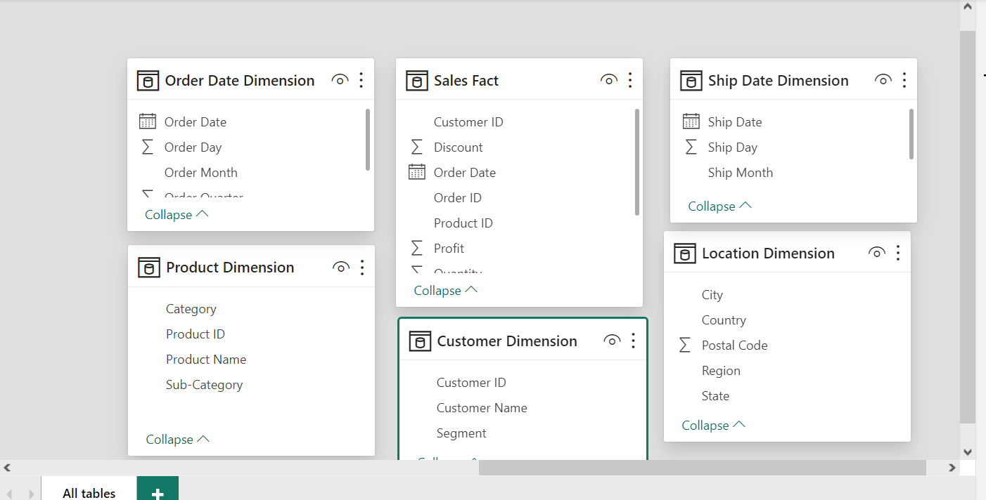

Fig 34: Model View after Data Cleaning.

**Creating Relationships between Dimension Tables & Fact Tables**

To create a relationship between the Dimension tables & fact table, the unique id column from the fact table would be dragged and placed on the same column in each dimension table. Below is what the model looks like after establishing these relationships.

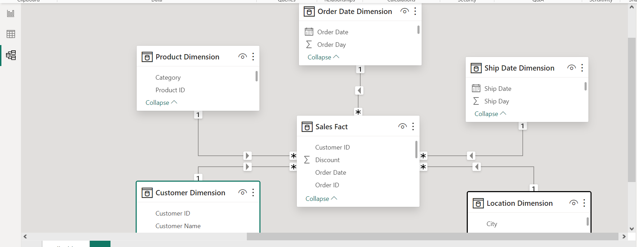

Fig 35: Model View showing Star Schema after relationships between fact & dimension tables have been created.

The relationship between the fact & dimension tables is a many-to-one relationship. Relationships of this kind improve data standardization, cut down on redundancy, and enable effective data retrieval and analysis. To maintain data consistency and integrity in a many-to-one relationship, the "many" side stores foreign keys that relate to the "one" side. This structure helps create a more structured and manageable database design and is especially useful for modelling hierarchies, categorizations, or reference tables.

**Changing Sales & Profit Format to Currency**

In the data view, the sales and profit column in the sales fact table would be changed to currency format. This is done by selecting the sales fact table in the data vie, and clicking on the sales column. In the column tools tab, the format drop-down button would be selected and currency would be selected. This would be done for both the sales & profit column

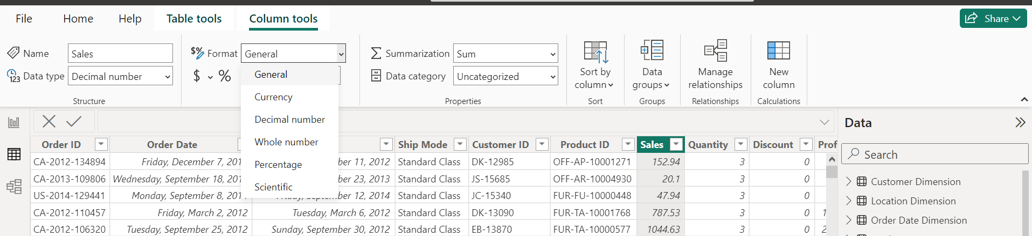

Fig 36: Changing Format to Currency

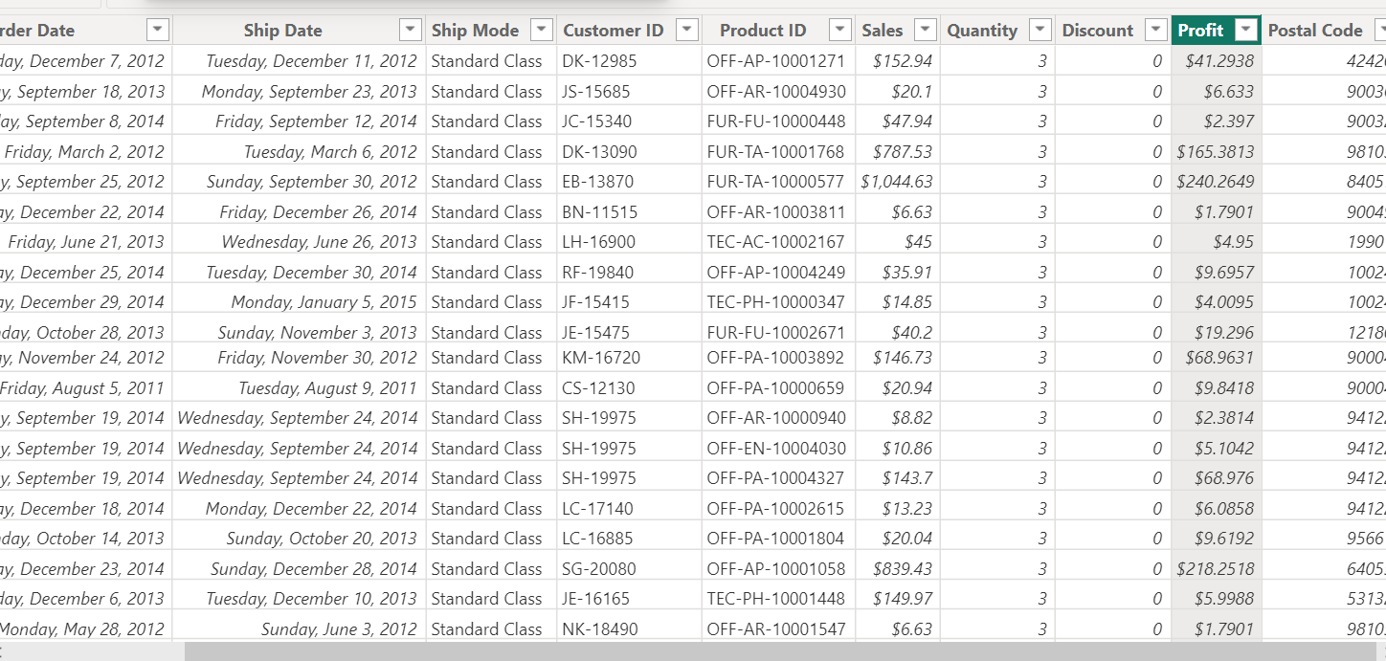

Fig 37: Sales & Profit Column after changing the format to currency.

# **Data Analysis Expressions (DAX)**

To create formulae and expressions in Power BI, Analysis Services, and Power Pivot in Excel data models, one can assemble a library of functions and operators called Data Analysis Expressions (DAX). A new table called Measure was created where all measures created in this analysis were stored. The Dax created and used in visualising and answering the BI question for each dashboard would be explained below.

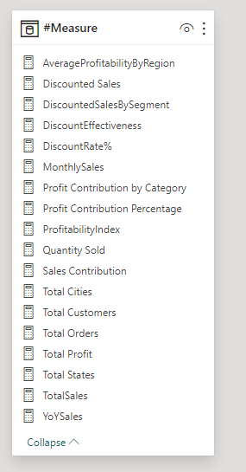

Fig 38: Measures table.

## **4.1 Sales Analysis Dashboard**

|  |  |  |
| --- | --- | --- |
| KPI & Measure | DAX Code | Description |
| Total Sales | TotalSales = SUM('Sales Fact'[Sales]) | This measure offers an overall aggregate of sales for all records. |
| Total Orders | Total Orders = COUNT('Sales Fact'[Order ID]) | This metric shows the total number of orders that have been recorded. |
| Quantity Sold | Quantity Sold = SUM('Sales Fact'[Quantity]) | This measure shows the total quantity of goods sold. |
| Year on Year Sales | YoYSales =  CALCULATE(  [TotalSales],  SAMEPERIODLASTYEAR('Order Date Dimension'[Order Date])  ) | Applying the total sales measure to the same period in the previous year through the SAMEPERIODLASTYEAR function on the 'Order Date Dimension' yields the year-over-year sales. |
| Monthly Sales | MonthlySales =  CALCULATE(  [TotalSales],  CROSSFILTER('Sales Fact'[Order Date], 'Order Date Dimension'[Order Date], BOTH)  ) | Undertaking a bidirectional cross-filter relationship between the 'Order Date' column in the 'Sales Fact' database and the 'Order Date' column in the 'Order Date Dimension' table, it computes the total sales. |

## **4.2 Geographical Pattern Dashboard**

|  |  |  |
| --- | --- | --- |
| KPI & Measures | DAX Code | Description |
| Total States | Total States = DISTINCTCOUNT('Location Dimension'[State]) | This measure calculated the total number of states in the record. |
| Total Cities | Total Cities = DISTINCTCOUNT('Location Dimension'[City]) | This measure calculated the total number of cities in the record |
| Average Profitability by Region | AverageProfitabilityByRegion =  DIVIDE(      SUM('Sales Fact'[Profit]),      CALCULATE(COUNTROWS('Sales Fact'), ALLEXCEPT('Location Dimension', 'Location Dimension'[Region]))  ) | The average profitability is determined by dividing the total profit by the number of rows, taking into account all regions inside the 'Location Dimension' with the exception of the context-relevant present region. |
| Total Profit | Total Profit = SUM('Sales Fact'[Profit]) | This metric shows the total earnings for all records combined. |
| Profitability Index | ProfitabilityIndex =  DIVIDE(      SUM('Sales Fact'[Profit]),      SUM('Sales Fact'[Sales])  ) | By dividing the total profit by the total sales, it determines the profitability index and yields a ratio that shows the proportion of profit in relation to sales. |

## **Discount Dynamics Dashboard**

|  |  |  |
| --- | --- | --- |
| KPI & Measures | DAX Code | Description |
| Total Discounted Sales | Discounted Sales = SUM(‘Sales Fact’[Discount]) | This metric shows the total amount of discounts applied to all records. |
| Total no of Customer | Total Customers = DISTINCTCOUNT(‘Customer Dimension’[Customer ID]) | This measure calculated the total number of customers in the record |
| Discount Rate | DiscountRate% = DIVIDE(SUM(‘Sales Fact’[Discount]), SUM(‘Sales Fact’[Sales]), 0) * 100 | By dividing the total amount of discounts by the total amount of sales and multiplying the result by 100, the discount rate percentage is computed. When the denominator is 0, the DIVIDE function replaces the result with zero to prevent division by zero problems. |
| Discount Effectiveness | DiscountEffectiveness = DIVIDE(SUM(‘Sales Fact’[Discount]),(‘#Measure’[TotalSales]), 0) | By dividing the total of all discounts by the total sales, it determines how effective discounts are. To address situations in which the total sales may be zero, the DIVIDE function is used, and zero is substituted for the result. |
| Discounted Sales by Segment | DiscountedSalesBySegment =  CALCULATE(      SUM(‘Sales Fact’[Discount]),      ALLEXCEPT(‘Customer Dimension’, ‘Customer Dimension’[Segment])  ) | Taking away all filters but the 'Segment' column in the 'Customer Dimension' table, it determines the total amount of discounts for every customer segment. |

## **4.4 Profitability Assessment Dashboard**

|  |  |  |
| --- | --- | --- |
| KPI & Measures | DAX Code | Description |
| Total Profit | Total Profit = SUM('Sales Fact'[Profit]) | This measure offers an overall aggregate of profit for all records. |
| Profit Contribution by Category | Profit Contribution by Category = SUM('Sales Fact'[Profit]) / CALCULATE(SUM('Sales Fact'[Profit]), ALL('Order Date Dimension')) | The measure determines the profit contribution for every category by dividing the overall earnings for the chosen category by the total profits for all categories, considering all values in the 'Order Date Dimension'. |
| Profit Contribution Percentage | Profit Contribution Percentage = DIVIDE([Total Profit], CALCULATE([Total Profit], ALL('Product Dimension'))) | The percentage contribution of profit for each product is determined by dividing the overall profit for the chosen product by the total profit for all products, taking into account all values in the 'Product Dimension'. |

## **4.4 Customer Analysis Dashboard**

|  |  |  |
| --- | --- | --- |
| KPI & Measure | DAX Code | Description |
| Total Customers | Total Customers = DISTINCTCOUNT('Customer Dimension'[Customer ID]) | This measure calculated the total number of customers in the record |
| Sales Contribution by Customers | Sales Contribution = '#Measure'[TotalSales] / CALCULATE(SUM('Sales Fact'[Sales]), ALLEXCEPT('Sales Fact', 'Customer Dimension'[Customer ID])) | It calculates the contribution of sales for each customer by dividing the total sales for the selected customer by the total sales across all customers, considering all values in the 'Customer Dimension' except the 'Customer ID'. |

# **Dashboard**

We will use data insights and visualizations during the analysis and evaluation phase to fully address the Business Intelligence (BI) questions that have been posed.

## **5.1 Home Page Dashboard**

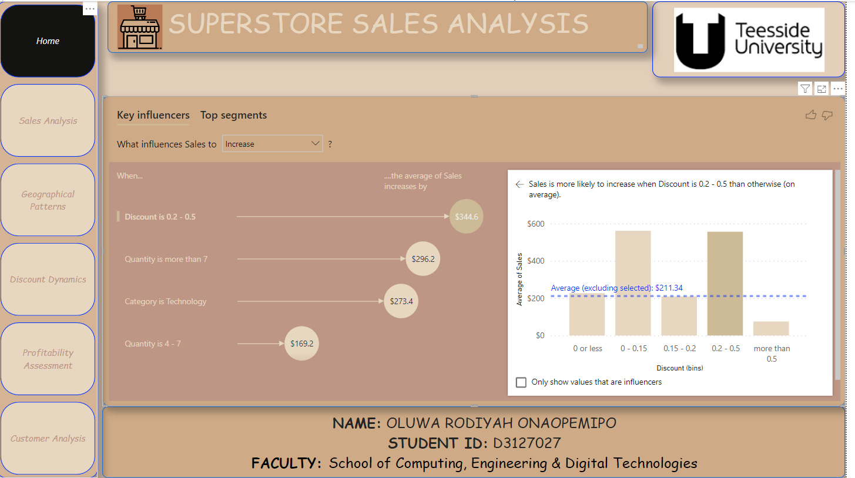

Fig 39: Home Page.

This page is the home page of this superstore sales analysis dashboard. It gives a general introduction into what the analysis is about.

It contains a page navigation button that allows easy movement to other pages in the dashboard. A text box for the name of the project and one for author description was created.

It also includes a key influencer chart, With the use of the Key Influencers visual in Power BI, one can determine key variables in your data by examining the correlations between various variables and determining which of them is most closely linked to a specific result. The Key Influencers chart shows which features influences “Sales” to increase and decrease.

It shows that sales increases when:

* Discount is 0.2 - 0.5.
* Quantity is more than 7.
* Category is Technology.
* Quantity is 4 - 7.

It also shows that sales decreases when:

* Category is Office Supplies.
* Quantity is 1 or less.
* Discount is more than 0.5.
* Quantity is 1 – 2.

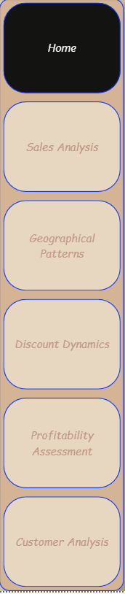

Fig 40: Page Navigation Button.

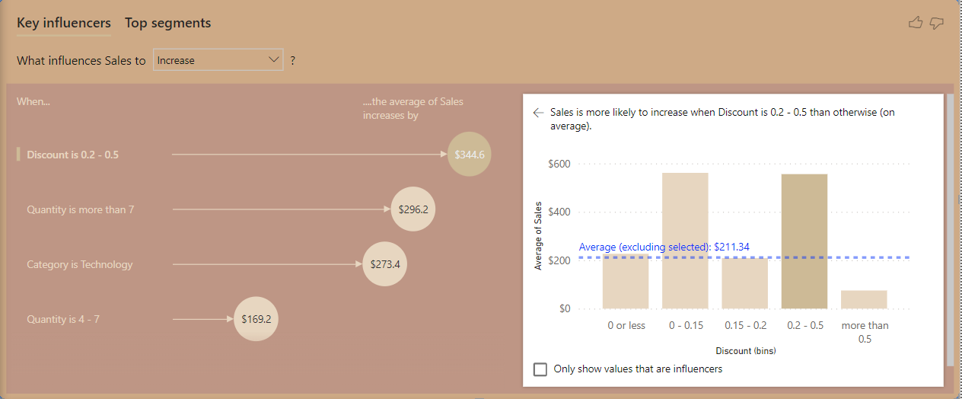

Fig 41: Key Influencers Chart.

## **5.1 Sales Analysis Dashboard**

To answer the fundamental business intelligence question, "Is there a seasonal pattern or trend in the volume of sales?" the Sales Analysis Dashboard was carefully created. In order to reveal complex patterns in the sales data, this extensive dashboard combines key performance indicators (KPIs) with aesthetically pleasing statistics.

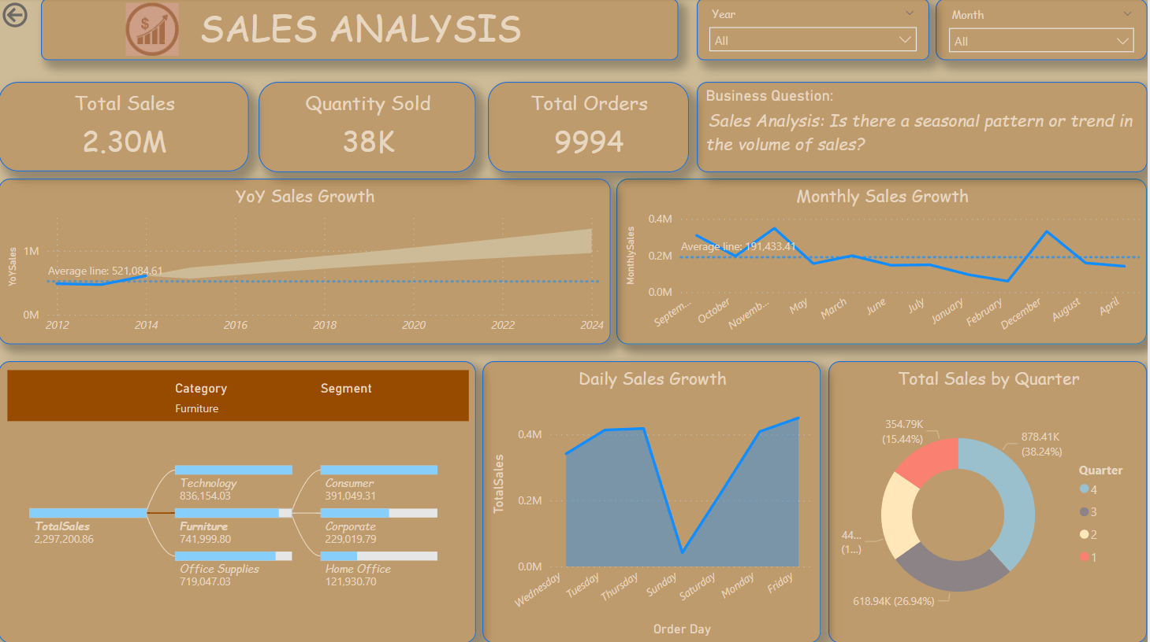

Fig 41: Sales Analysis Dashboard.

The sales analysis dashboard includes various visualisation. The visuals include card visuals, line chart, decomposition tree, area chart, slicers and a donut chart. It also includes text boxes and a navigation button.

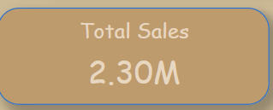

Fig 42: Total Sales Card Visual.

BI Question: What’s the total sales generated?

KPI: Total Sales

DAX Formula: TotalSales = SUM('Sales Fact'[Sales])

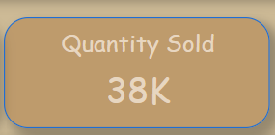

Fig 43: Total Quantity Sold Card Visual.

BI Question: What’s the total quantity sold recorded?

KPI: Total Quantity Sold

DAX Formula: Quantity Sold = SUM('Sales Fact'[Quantity])

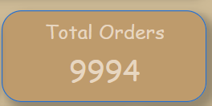

Fig 44: Total Number of Orders Card Visual.

BI Question: What’s the total number of orders recorded?

KPI: Total No of Orders

DAX Formula: Total Orders = COUNT('Sales Fact'[Order ID])

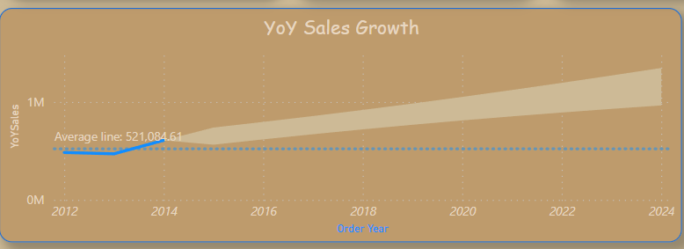

Fig 45: YoY Sales Growth Line Chart.

BI Question: What’s the year-over-year growth rate in sales?

KPI: YoY Sales Growth

DAX Formula: YoYSales =CALCULATE([TotalSales], SAMEPERIODLASTYEAR('Order Date Dimension'[Order Date]))

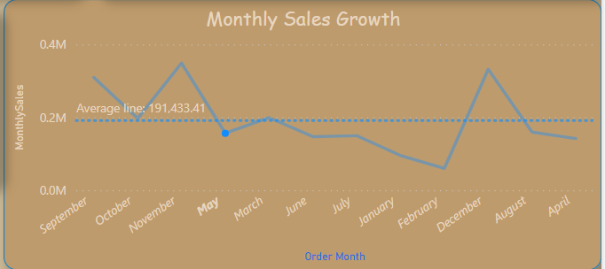

Fig 46: Monthly Sales Growth Line Chart.

BI Question: What’s the monthly growth rate in sales?

KPI: Monthly Sales Growth

DAX Formula: MonthlySales = CALCULATE([TotalSales],CROSSFILTER('Sales Fact'[Order Date], 'Order Date Dimension'[Order Date], BOTH))

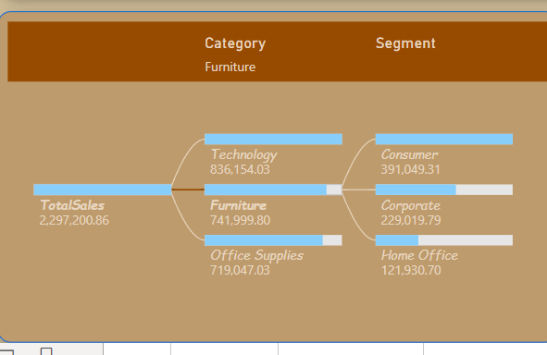

Fig 47: Decomposition Tree.

BI Question: What’s the contribution of each product category and customer segment to total sales?

KPI: Contribution of Product category and consumer segment to total sales

DAX Formula: TotalSales = SUM('Sales Fact'[Sales])

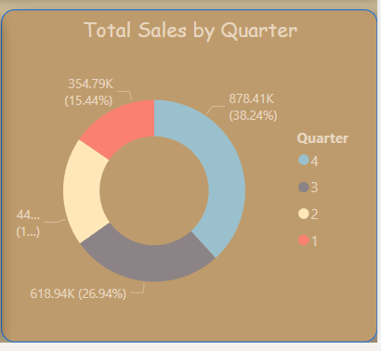

Fig 48: Donut Chart.

BI Question: What’s the contribution of each quarter to total sales?

KPI: Contribution of quarter to total sales

DAX Formula: TotalSales = SUM('Sales Fact'[Sales])

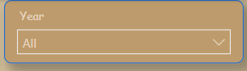

Fig 49: Year Slicer.

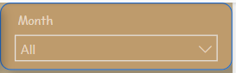

Fig 50: Month Slicer.



Fig 51: A Text Box that shows the title of the Dashboard.

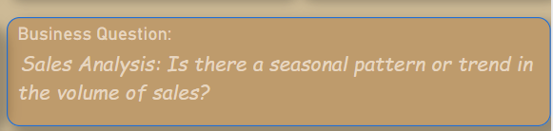

Fig 52: A Text Box that shows Overall BI Question answered in the Dashboard.



Fig 53: A navigation button to navigate through various pages in the Dashboard.

This Sales analysis dashboard gives an overview of the total sales generated in this record, total quantity sold and the total number of orders recorded, YoY sales growth, Monthly sales growth, daily sales growth, total sales generated per quarter, and total sales generated by each product category and customer segment. It also shows a forecast of YoY sales growth to be generated in coming years with a 95% confidence interval.

The major overviews highligted are:

1. Total Sales generated from 2011 to 2014 was 2.30M
2. Total Quantity Sold within the period recorded was 38k
3. Total number of orders received was 9994
4. 2014 had a higher sales growth compared to the other years
5. Forecast on YoY sales shows that there’d be a constant increase in the sales generated yearly
6. November had the highest montly sales growth, while febuary had the lowest
7. Friday had the highest daily sales growth while Sunday had the lowest.
8. More sales were generated in the 4th Quarter of the year.
9. Technology is the product category that generated the highest total sales, while office supplies had the lowest.
10. Consumers were the customer segment with the highest sales while home office generated the lowest sales.

## **5.5 Geographical Pattern Dashboard**

To answer the fundamental business intelligence question," Is there any geographic pattern that influences profitability & Sales?*"* the Geographical Pattern Dashboard was created. In order to reveal complex patterns in the data related to various locations, this extensive dashboard combines key performance indicators (KPIs) with aesthetically pleasing statistics.

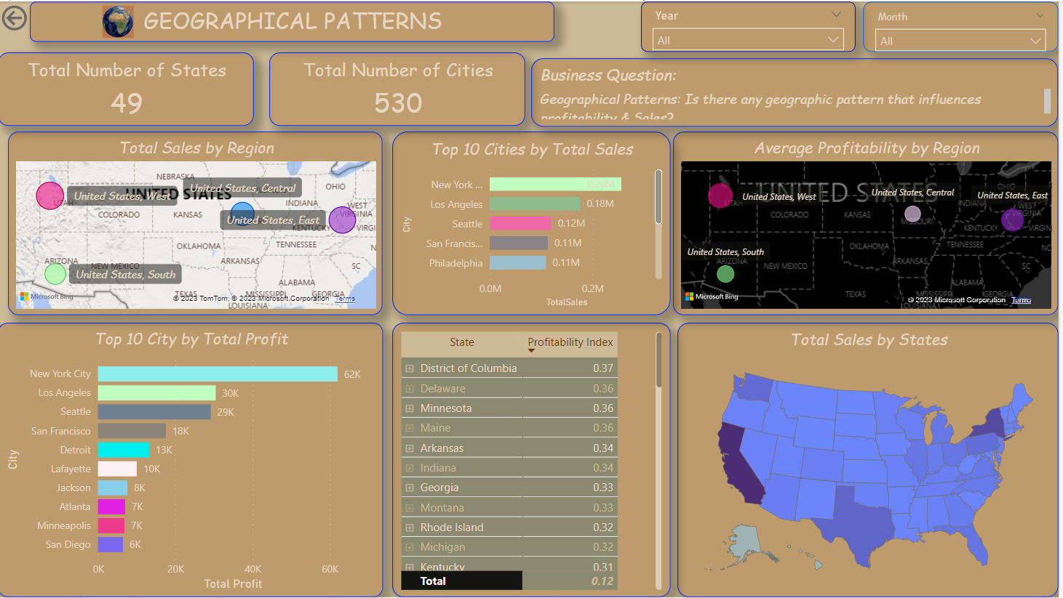

Fig 54: Geographical Patterns Dashboard.

The geographical pattern dashboard includes various visualisation. The visuals include card visuals, slicers, map, shape map, stacked bar chart and a matrix. It also includes text boxes and a navigation button.

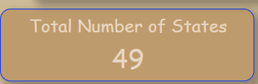

Fig 55: Total number of States.

BI Question: What’s total number of states being operated within?

KPI: Total Number of States

DAX Formula: Total States = DISTINCTCOUNT('Location Dimension'[State])

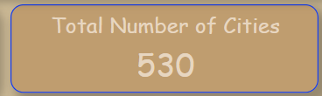

Fig 56: Total number of Cities.

BI Question: What’s total number of cities being operated within?

KPI: Total Number of Cities

DAX Formula: Total Cities = DISTINCTCOUNT('Location Dimension'[City])



Fig 57: Text box showing title of the page.



Fig 58: Year Slicer.



Fig 59: Month Slicer.

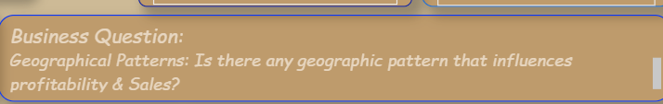

Fig 60: Text Box showing overall BI question being answered.

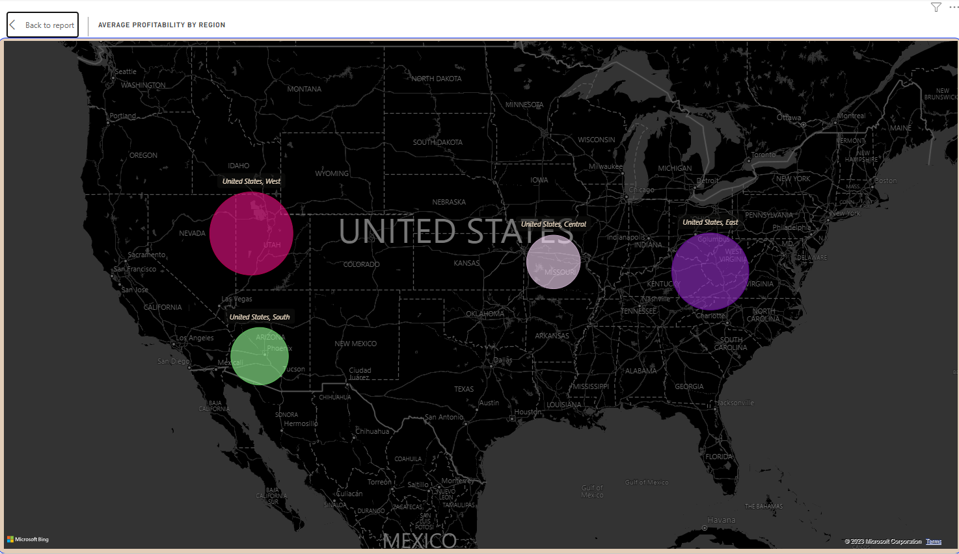

Fig 61: Average Profitability by Region.

BI Question: What’s average profitability generated from each region?

KPI: Average Profitability by Region

DAX Formula: AverageProfitabilityByRegion = DIVIDE(SUM('Sales Fact'[Profit]),CALCULATE(COUNTROWS('Sales Fact'), ALLEXCEPT('Location Dimension', 'Location Dimension'[Region])))

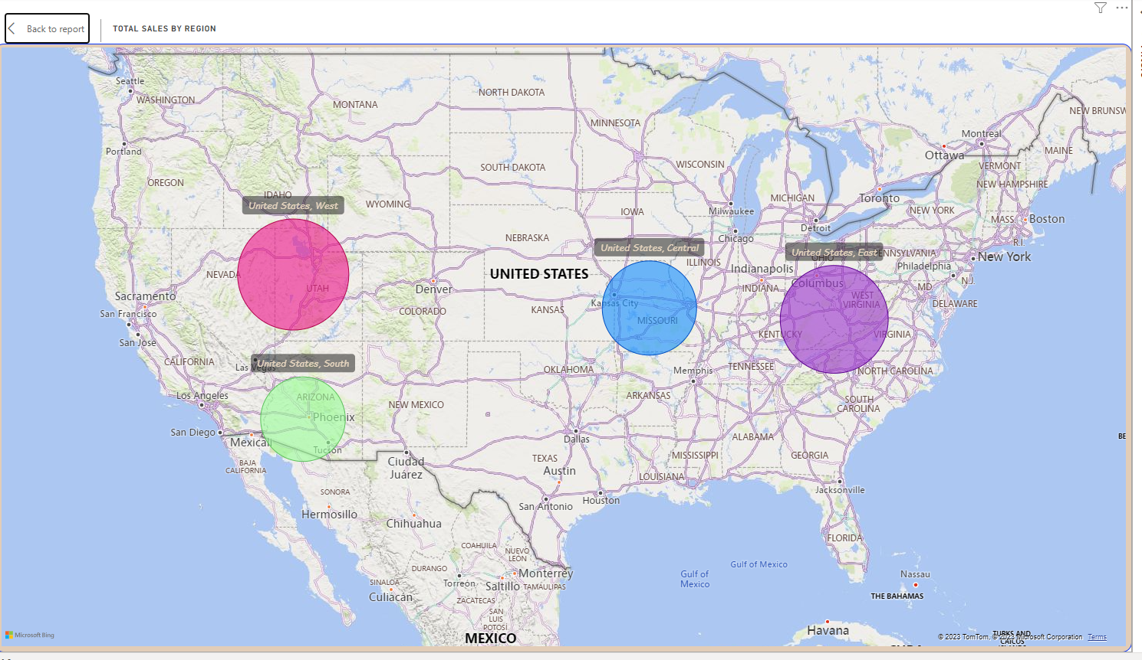

Fig 62: Total Sales by Region.

BI Question: What’s the total sales generated from each region?

KPI: Total Sales by Region

DAX Formula: TotalSales = SUM('Sales Fact'[Sales])

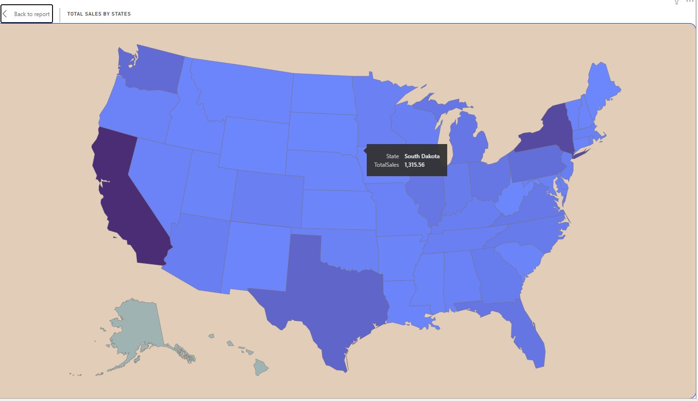

Fig 63: Total Sales by States.

BI Question: What’s the total sales generated from each state?

KPI: Total Sales by States

DAX Formula: TotalSales = SUM('Sales Fact'[Sales])

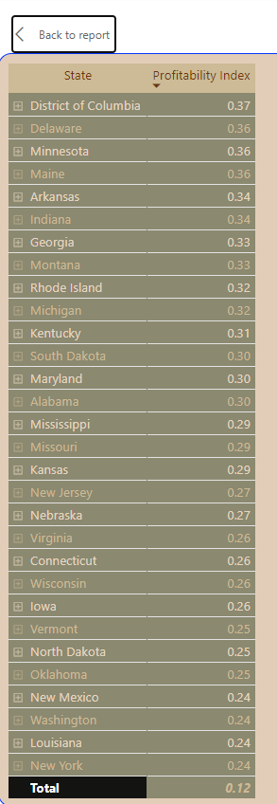

Fig 64: Profitability index by city.

BI Question: What’s Profitability index for each city?

KPI: Cities Profitability Index

DAX Formula: ProfitabilityIndex = DIVIDE(SUM('Sales Fact'[Profit]),SUM('Sales Fact'[Sales]))

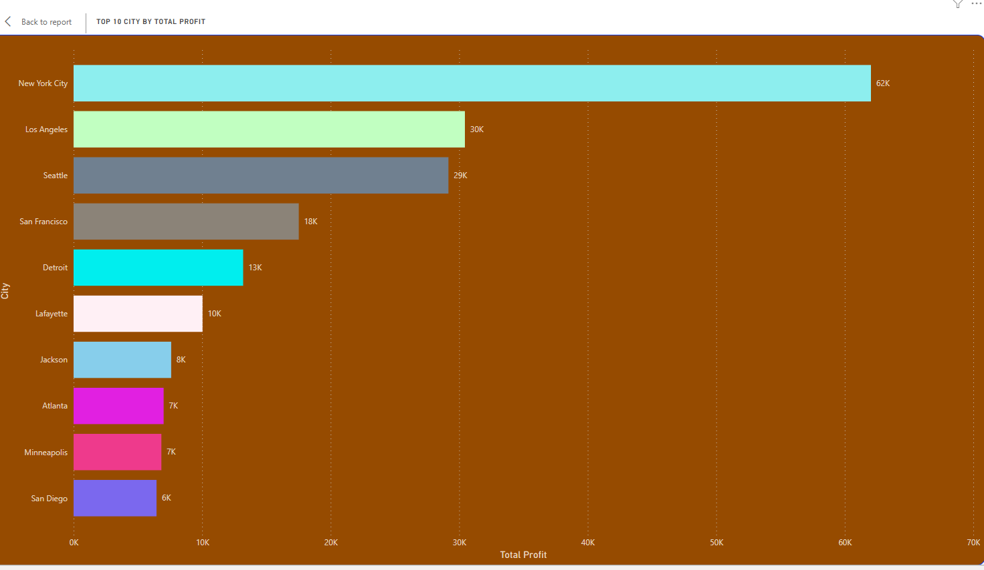

Fig 65: Top 10 Cities by Total Profit

BI Question: What are top cities that generated the highest profits?

KPI: Top 10 Cities by Total Profit

DAX Formula: Total Profit = SUM('Sales Fact'[Profit])

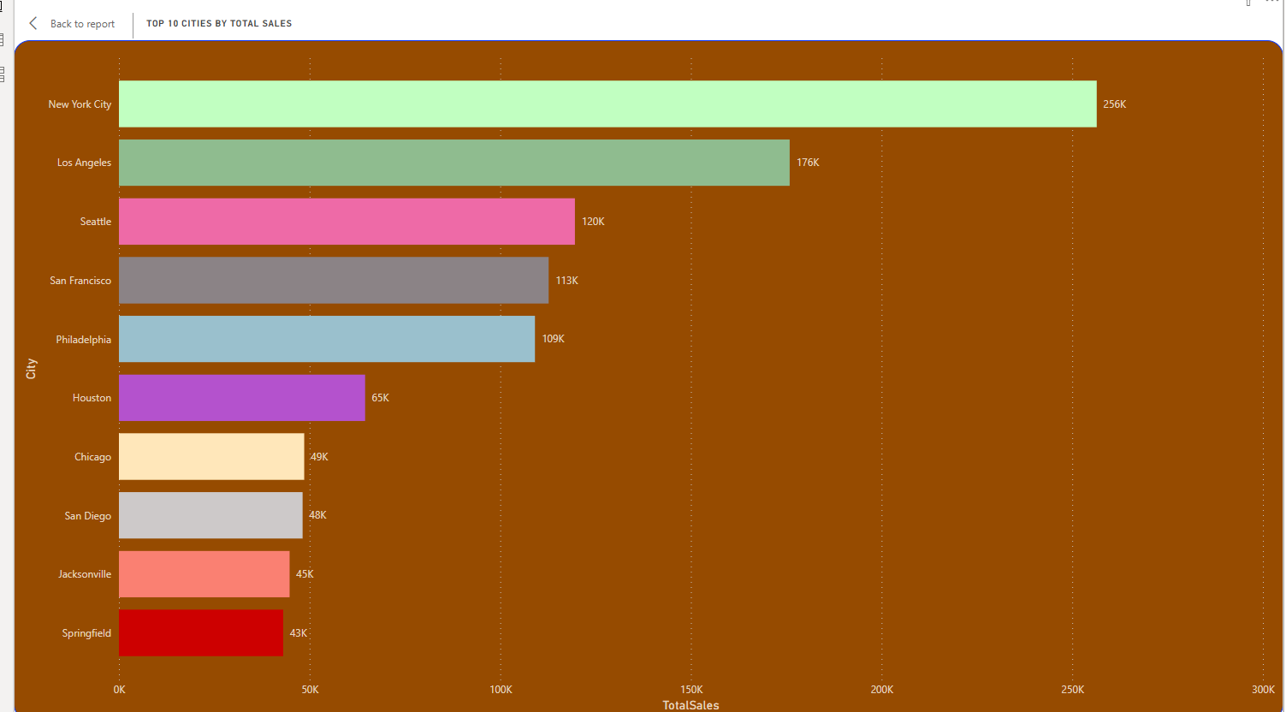

Fig 66: Top 10 Cities by Total Sales

BI Question: What are top cities that generated the highest sales?

KPI: Top 10 Cities by Total Sales

DAX Formula: Total Sales = SUM('Sales Fact'[Sales])

This Geographical Pattern dashboard gives an overview of the total number of states and cities this organisation operates within, it includes a map that shows the regions with the highest and lowest number of sales generated, bar charts that show the top 10 cities by total sales and total profit, a map that shows the average profitability generated by each region, a shape mp that shows the total sales by states and a matrix that shows the profitability index for each city,

The major overviews highligted are:

1. Total Number of states the organisation operates is 49
2. There is a total number of 530 cities.
3. The west generated the highest number of sales while the south generated the lowest
4. The west had the highest average profitability while the cemntral had the lowest.
5. New York city generated the highest number of sales and profit.
6. District of Columbia is the city with the highest profitability index.
7. California is the state with highest number of sales recorded.

## **5.6 Discount Dynamics Dashboard**

To answer the fundamental business intelligence question," What effects does discount have on sales, quantity sold, customer segmentation, profitability?" the Discount Dynamics Dashboard was created. In order to reveal complex patterns in the data related to discount, this extensive dashboard combines key performance indicators (KPIs) with aesthetically pleasing statistics.

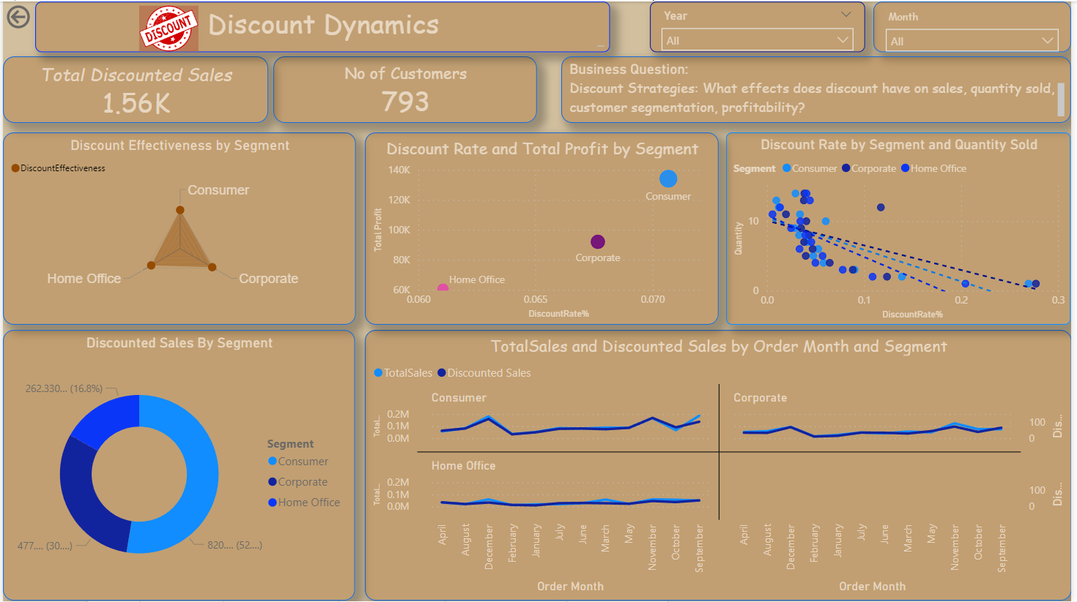

Fig 67: Discount Dynamics Dashboard.

The discount dynamics dashboard includes various visualisation. The visuals include card visuals, slicers, radar chart, donut chart, scatter charts and a multiple line chart. It also includes text boxes, a trend line and a navigation button.

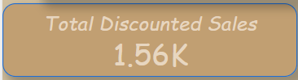

Fig 68: Total Discounted Sales

BI Question: What is the total amount of discount given?

KPI: Total Discounted Sales

DAX Formula: Discounted Sales = SUM(‘Sales Fact’[Discount])



Fig 69: Total No of Customers

BI Question: What is the total no of customers?

KPI: Total Number of Customers

DAX Formula: Total Customers = DISTINCTCOUNT(‘Customer Dimension’[Customer ID])

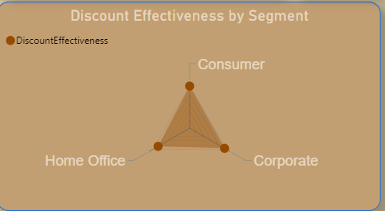

Fig 70: Discount Effectiveness by Segment

BI Question: Which discount effectiveness for each consumer segment?

KPI: Discount Effectiveness by Segment

DAX Formula: DiscountEffectiveness = DIVIDE(SUM(‘Sales Fact’[Discount]),(‘#Measure’[TotalSales]), 0)

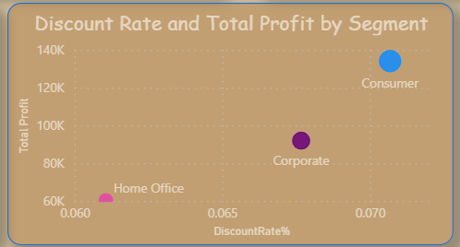

Fig 71: Discount rate and total profit by customer segment

BI Question: Which effect did the discount rate for each customer segment have on the total profit generated for that segment?

KPI: Discount Rate and total profit by customer segment

DAX Formula: DiscountRate% = DIVIDE(SUM(‘Sales Fact’[Discount]), SUM(‘Sales Fact’[Sales]), 0) * 100

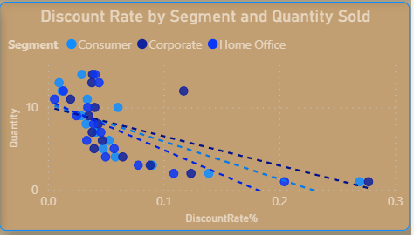

Fig 72: Discount rate by customer segment and quantity sold.

BI Question: Which is the trend between discount rate for each customer segment and total quantity sold for that segment?

KPI: Trend of Discount Rate and quantity sold by customer segment

DAX Formula: DiscountRate% = DIVIDE(SUM(‘Sales Fact’[Discount]), SUM(‘Sales Fact’[Sales]), 0) * 100

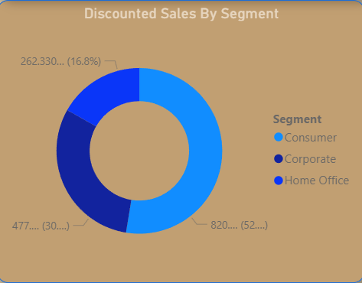

Fig 73: Discounted Sales by Segment

BI Question: Which customer segment had the highest number of discounted sales?

KPI: Trend of Discount Rate and quantity sold by customer segment

DAX Formula: DiscountedSalesBySegment = CALCULATE( SUM(‘Sales Fact’[Discount]),ALLEXCEPT(‘Customer Dimension’, ‘Customer Dimension’[Segment]))

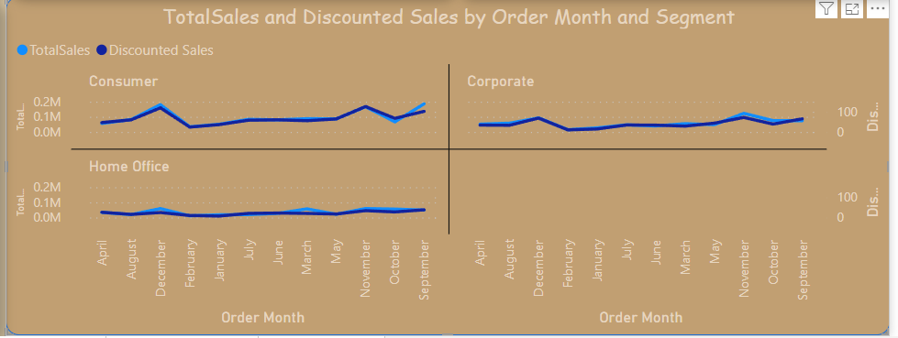

Fig 74: Total Sales and Discounted sales by order month and segment

BI Question: What monthly effect did the discount have on total sales for each segment?

KPI: Monthly trend of relationship between discount and total sales for each segment

DAX Formula: Discounted Sales = SUM(‘Sales Fact’[Discount])



Fig 75: Text box showing overall BI question answered.



Fig 76: Text box showing tittle of Dashboard.

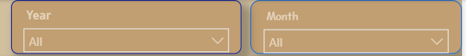

Fig 77: Year and Month Slicers

This Discount Dynamics dashboard gives an overview of the total amount of discount recorded and the total no of customers the organisation has. It includes a radar chart that shows the discount effectiveness for each segement, scatter plots that show the discount rate by total profit and quantity sold for each segment, donut chart showing total discounted sales by segment and a multi-line chart showing the monthly total sales and discounted sales for each segment.

The major overviews highligted are:

1. Total discounted sales recorded was 1.56k.
2. There is a total number of 793 Customers.
3. Consumer was the segment with the highest discount effectiveness
4. There’s a positive relationship between discount rate and total profit. i.e as discount rate increased total profit also increased.
5. There’s a negative relationship between discount rate and quantity sold. i.e as discount rate increased quantity sold decreased.
6. Consumer Segment is the segment with the highest discounted sales.
7. Consumer segment had a higher discounted sales which also led to them generating more monthly sales.

## **5.6 Profitability Assessment Dashboard**

To answer the fundamental business intelligence question," Which product or product category makes the biggest contribution to total profitability?" the Profitability Assessment Dashboard was created. In order to reveal complex patterns in the data related to profit, this extensive dashboard combines key performance indicators (KPIs) with aesthetically pleasing statistics.

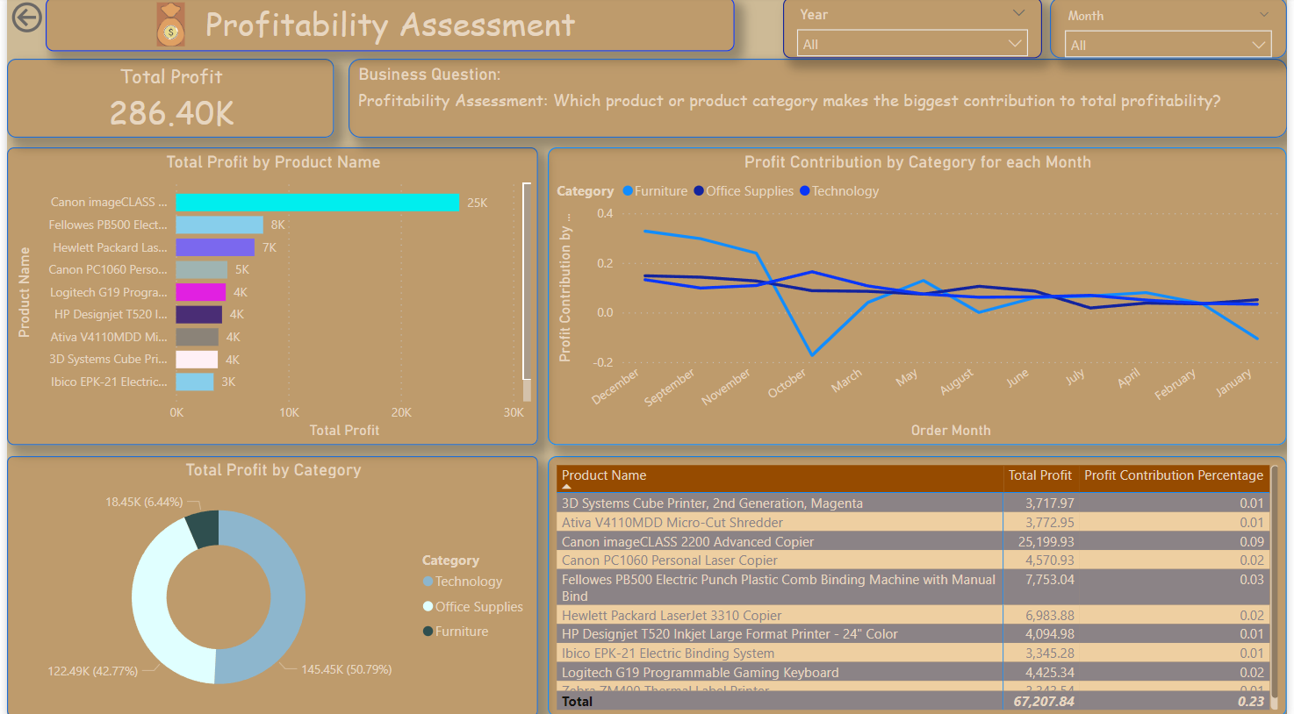

Fig 78: Profitability Assessment Dashboard.

The profitability assessment dashboard includes various visualisation. The visuals include card visuals, slicers, bar chart, line chart, donut chart and a matrix. It also includes text boxes and a navigation button.



Fig 79: Total Profit Card

BI Question: What is the total profit generated?

KPI: Total Profit

DAX Formula: Total Profit = SUM('Sales Fact'[Profit])

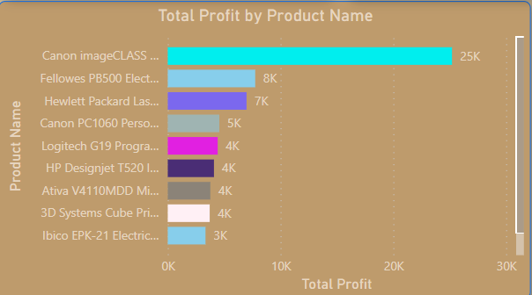

Fig 80: Total Profit by Product Name

BI Question: What product generated the highest profit?

KPI: Total Profit by Product Name

DAX Formula: Total Profit = SUM('Sales Fact'[Profit])

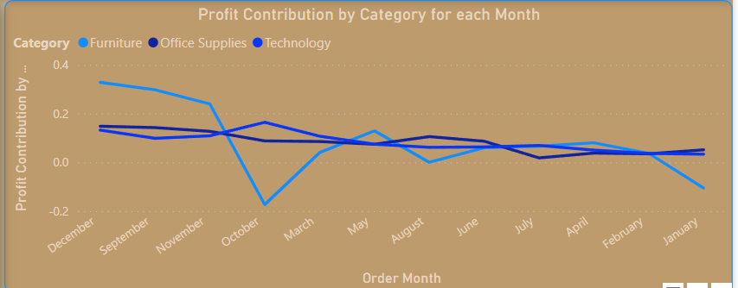

Fig 81: Monthly Profit Contribution by Category

BI Question: What is the monthly profit contribution by category?

KPI: Monthly Profit Contribution by Category

DAX Formula: Profit Contribution by Category = SUM('Sales Fact'[Profit]) / CALCULATE(SUM('Sales Fact'[Profit]), ALL('Order Date Dimension'))

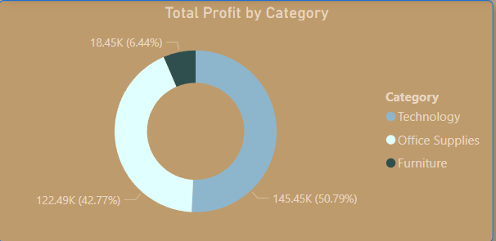

Fig 82: Total Profit by Category

BI Question: What is the total profit generated by various category?

KPI: Total Profit by Category

DAX Formula: Total Profit = SUM('Sales Fact'[Profit])

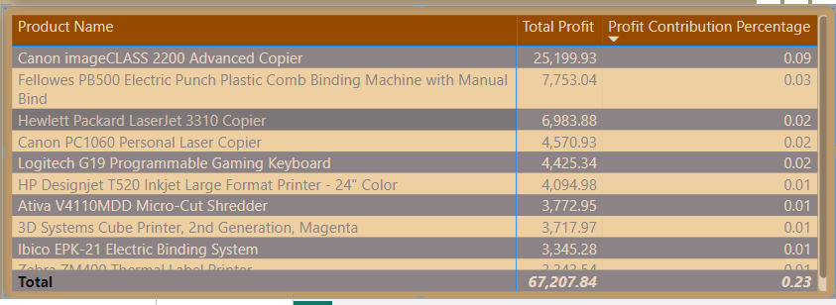

Fig 83: Total Profit and profit contribution percentage for each Product

BI Question: What is the total profit and profit contribution percentage generated by each product?

KPI: Total Profit and profit contribution percentage for each Product

DAX Formula: Profit Contribution Percentage = DIVIDE([Total Profit], CALCULATE([Total Profit], ALL('Product Dimension')))



Fig 84: Text box showing title of Dashboard.



Fig 85: Text box showing overall BI question answered

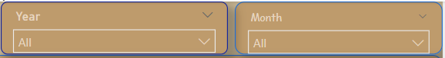

Fig 86: Year and Month Slicers.

This Profitability Assessment dashboard gives an overview of the total amount of profit generated. It includes a bar chart showing the total profit generated by each segment, a donut chart ahowing the product category that generated the highest profit,a matrix showing the profit and profit contribution percentahe generated for each product, a line chart showing the profit contribution by category for each month.

The major overviews highligted are:

1. Total profit generated was 286.40k.
2. Canon Image Class 2200 Advanced Copier was the product that generated the most profit.
3. Technology was the product category that generated the highest profit.
4. Canon Image Class 2200 Advanced Copier was the product that had the highest profit and profit contribution by percentage .

## **5.7 Customer Analysis Dashboard**

To answer the fundamental business intelligence question," What insights may be obtained by examining the overall sales generated based on the customer's choice of ship method, and how do individual customer preferences affect both sales and profitability?" the Customer Analysis Dashboard was created. In order to reveal complex patterns in the data related to customers, this extensive dashboard combines key performance indicators (KPIs) with aesthetically pleasing statistics.

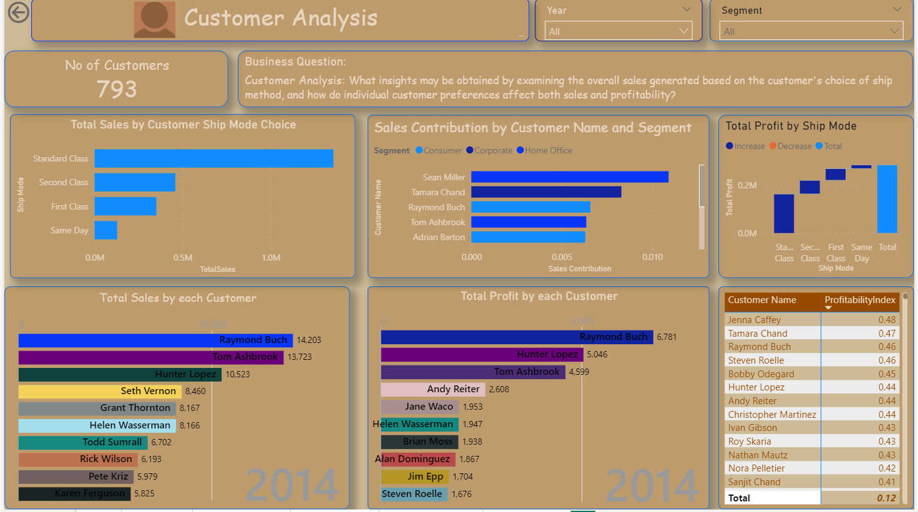

Fig 87: Customer Analysis Dashboard.

The customer analysis dashboard includes various visualisation. The visuals include card visuals, slicers, clustered bar chart, stacked bar chart, water fall chart, animated bar chart race and a matrix. It also includes text boxes and a navigation button.



Fig 88: Total No of Customers

BI Question: What is the total number of customers?

KPI: Total Profit by Category

DAX Formula: Total Customers = DISTINCTCOUNT('Customer Dimension'[Customer ID])

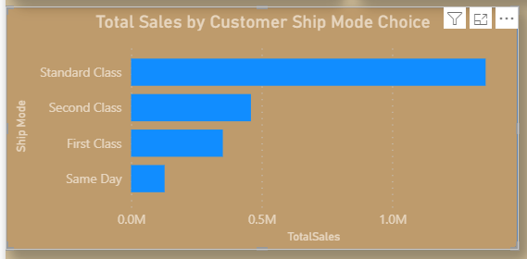

Fig 89: Total sales by customers ship mode choice.

BI Question: What are the total sales generated by each ship mode choices?

KPI: Total Sales by Ship Mode Choices

DAX Formula: TotalSales = SUM('Sales Fact'[Sales])

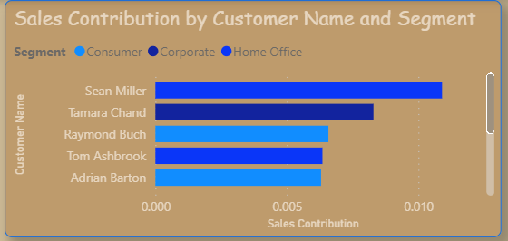

Fig 90: Sales Contribution by customer name and segment

BI Question: What is the sales contribution by each customer name and segment?

KPI: Sales Contribution by customer name and segment

DAX Formula: Sales Contribution = '#Measure'[TotalSales] / CALCULATE(SUM('Sales Fact'[Sales]), ALLEXCEPT('Sales Fact', 'Customer Dimension'[Customer ID]))

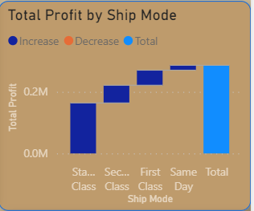

Fig 91: Total Profit by Ship Mode

BI Question: What is the total profit generated by each ship mode?

KPI: Total Profit by Ship Mode

DAX Formula: Total Profit = SUM('Sales Fact'[Profit])

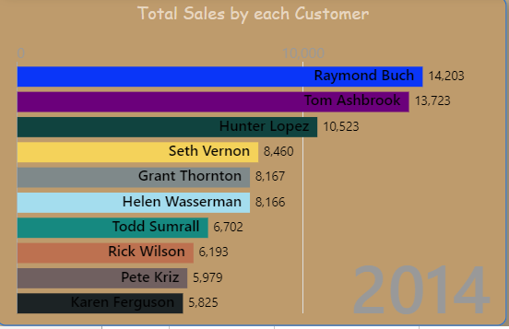

Fig 92: Yearly total Sales contribution by each Customer

BI Question: What is the yearly sales contribution by each customer?

KPI: Yearly sales contribution by each customer

DAX Formula: TotalSales = SUM('Sales Fact'[Sales])

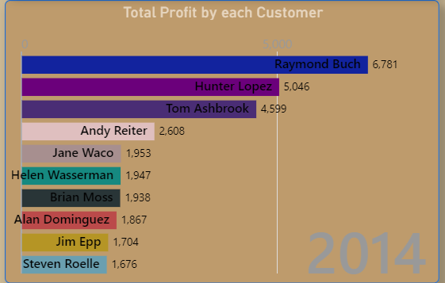

Fig 93: Yearly total profit contribution by each Customer

BI Question: What is the yearly profit contribution by each customer?

KPI: Yearly profit contribution by each customer

DAX Formula: Total Profit = SUM('Sales Fact'[Profit])

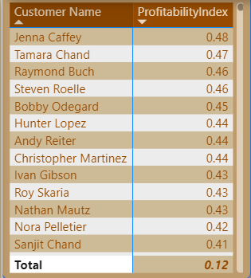

Fig 94: Profitability Index for each Customer

BI Question: What is the profitability index for each customer?

KPI: Profitability Index for Customers

DAX Formula: ProfitabilityIndex = DIVIDE(SUM('Sales Fact'[Profit]),SUM('Sales Fact'[Sales]))

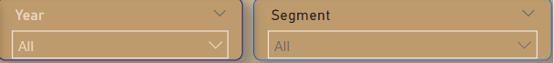

Fig 93: Year and Segment Slicers



Fig 94: Text Box showing title of Dashboard.



Fig 95: Text Box showing Overall BI question answered.

This Customer Analysis dashboard gives an overview of the total number of customers using a card visual. It includes a clustered bar chart showing the total sales by consumers ship mode choices, a stacked bar chart showing the sales contribution by customer name and segment, a waterfall chart showing the total profit generated from each ship mode, animated bar chart race showing the total sales and profit generated from each customers. A matrix showing the profitability index of each customer.

The key insights highligted are:

1. Total No of Customers is 793.
2. Standard Class is the ship mode that generated the highest sales.
3. Standard Class is the ship mode that generated the highest profit.
4. Raymond Buch is the customer that generated the highest sales and profit.
5. Jenna Caffey was the customer with the highest profitability index.
6. Sean Miller a customer from the consumer segment had the highest sales contribution.

# **6. Technical Details (Appendix)**

* Data Source: The dataset used in this analysis was gotten from Kaggle:

<https://www.kaggle.com/datasets/ishanshrivastava28/superstore-sales>

* Power BI desktop: Version: 2.124.1052.0 64-bit (December 2023)

# **STAKEHOLDER REPORT**

# **1. Introduction**

## **1.1 Executive Summary**

Data has become essential in the fast-paced retail industry, where market dynamics are always shifting, and consumer tastes are evolving at a quick pace. Understanding consumer behaviour, effectively controlling inventory, and quickly responding to market developments are critical success factors for the retail industry. Business intelligence (BI) stands out as a game-changer in this situation, giving retailers the analytical capabilities, they need to successfully negotiate this shifting terrain.

The retail sector is known for its diversity, which includes a large range of goods, services, and business strategies. It functions in a fiercely competitive market where success depends on fast decision-making, operational effectiveness, and customer happiness. Retailers must manage their inventories, optimise their supply chains, and provide individualised consumer experiences in order to remain competitive.

BI is essential to turning massive volumes of data into useful insights in the retail industry. Retailers may examine sales patterns, consumer preferences, and operational performance with the use of BI technologies. Retail organisations can improve customer satisfaction, streamline operations, and make well-informed decisions by utilising business intelligence (BI).

Retailers looking to leverage their data can gain a strategic advantage by utilising Power BI, a powerful business analytics solution. Retail professionals can easily visualise and comprehend data with Power BI thanks to its user-friendly interface and easy integration features. Power BI enables merchants to take data-driven decisions that improve their bottom line by tracking inventory levels and sales performance.

The Power BI integration prepares us for the exploration of the retail industry-specific dataset and the discovery of insightful information that can spur growth, improve customer satisfaction, and streamline operations in the ever-changing retail environment.

## **1.2 Data Source**

The main source of the dataset used in this study was Kaggle: <https://www.kaggle.com/datasets/ishanshrivastava28/superstore-sales>

Numerous characteristics about specific orders are included in the dataset, including the date of the transaction, the method of shipment, the demographics of the customers, the types of products sold, the amount paid, the discounts offered, and the profits. Our investigation of regional patterns and trends is made possible by the dataset's inclusion of geographic data. We can learn more about various retail operations-related topics by utilising this dataset.

Below is a detailed description of the dataset.

|  |  |  |
| --- | --- | --- |
| Index | Columns | Description |
| 1 | Row ID | An individual number for every row in the dataset |
| 2 | Order ID | A distinct number is assigned to every order |
| 3 | Order Date | The date the order was placed |
| 4 | Ship Date | The date the order was shipped to the customer |
| 5 | Ship Mode | The mode of shipping the order |
| 6 | Customer ID | A distinct number assigned to every customer |
| 7 | Customer Name | The name of the customer |
| 8 | Segment | The customer segment |
| 9 | Country | The country where the order was placed |
| 10 | City | The city where the order was placed |
| 11 | State | The state where the order was placed |
| 12 | Postal Code | The postal code of the location |
| 13 | Region | The region in the country where the order was placed |
| 14 | Product ID | A distinct number assigned to every product |
| 15 | Category | The category where the product falls (e.g., Furniture) |
| 16 | Sub-Category | The sub-category of the product (e.g., chairs) |
| 17 | Product Name | The name of the product |
| 18 | Sales | The total sales generated from the order |
| 19 | Quantity | The number of products ordered |
| 20 | Discount | The discount applied to the order |
| 21 | Profit | The profit generated from the order |

Table 3: Superstore Sales Variables and Descriptions

# **2. BI Solution Overview**

## **2.1 BI KPI Requirements and Questions**

### **KPI Requirements**

Key Performance Indicators are essential measurements used to assess how well corporate objectives are being met. KPIs are intended to provide actionable insights into sales dynamics, geographic trends, the efficacy of discounts, profitability, and consumer behaviour within the framework of our business intelligence architecture. Metrics like Discounted Sales, Average Profitability by Region, Monthly Sales Growth Rate, and Total Sales by Ship Method are examples of these indicators. Sales managers, the marketing team, and executives have distinct demands, and KPIs are designed to address those needs by giving them quantitative measurements to evaluate performance, make data-driven decisions, and optimise their own plans.

### **High Level Scope for Analysis & Visuals**

The high-level scope highlights a thorough approach to data analysis by outlining the depth and breadth of our analytics and graphics. Analytics will examine complex patterns in sales data to provide a more detailed picture of consumer behaviour, regional variations, and the effects of discounting tactics. A variety of graphs and charts will be included in the visuals, such as bar charts for profitability analysis, spider charts for discount efficacy, maps for regional insights, and line charts for sales trends. This breadth makes sure that our BI system offers a comprehensive picture in addition to specific responses, enabling a thorough understanding of the business environment to support well-informed decision-making at all organisational levels.

### **Business Intelligence Questions**

The business intelligence questions that this analysis aims to answer are:

1. Sales Analysis: Is there a seasonal pattern or trend in the volume of sales?
2. Geographical Patterns: Is there any geographic pattern that influences profitability & Sales?
3. Discount Strategies: What effects does discount have on sales, quantity sold, customer segment, profitability?
4. Profitability Assessment: Which product or product category makes the biggest contribution to total profitability?
5. Customer Analysis: What insights may be obtained by examining the overall sales generated based on the customer's choice of ship method, and how do individual customer preferences affect both sales and profitability?

### **Key User Groups**

1. Sales Managers:

Sales analysis is a valuable tool for sales managers to spot trends, pinpoint high-performing goods, and enhance their marketing approaches. Discount strategies are essential for them to comprehend the efficacy of discounts, adjust pricing, and strategically motivate sales personnel. Furthermore, in order to maintain long-term business growth and profitability, profitability assessment helps sales managers concentrate their efforts on high-margin items and customer segments.

1. Marketing Team:

The Marketing Team's interest on Geographical Patterns enables them to customise campaigns according to local tastes, guaranteeing focused and culturally appropriate advertising. The team may optimise marketing efforts for maximum impact by using sales analysis, which offers vital information into client segments and product popularity. Understanding the efficacy of discounts is another aspect of their focus on discount strategies, which helps the team create promotions that appeal to consumers and increase sales.

1. Executives:

Executives use the Profitability Assessment to set resource priorities, concentrating on critical business sectors and high-margin items. Geographical patterns support the identification of worldwide market trends, the direction of expansion plans, and the alignment of the organisation with a variety of market circumstances. Moreover, customer analysis gives executives insights into personal preferences, enabling customised plans and cultivating enduring customer relationships that are essential for long-term company success.

### **Necessity of Information**

1. Sales Managers:

Sales managers need real-time insights to quickly adjust their sales strategy in response to changing market conditions. Having access to real-time data enables them to take rapid, well-informed decisions, which guarantees flexibility in handling obstacles and seizing new opportunities.

1. Marketing Team:

The Marketing Team needs data in order to develop campaigns that appeal to its target audiences. With real-time analytics, the team can dynamically modify marketing strategies to keep campaigns relevant and successful in a market that is changing quickly.

1. Executives:

Comprehensive reports provide executives with a comprehensive understanding of the functioning of their organisations. Executives may recognise broad patterns with the help of this integrated picture, which enables them to make strategic decisions that support the organization's long-term objectives. Consolidated reports also make it easier for leadership teams to collaborate and communicate effectively.

## **2.2 Methodology**

An organised and methodical strategy is necessary for the successful extraction, processing, and display of data while implementing a business intelligence (BI) system. We used the following methodology and strategies in the context of our retail industry dataset:

### **Data Collection and Integration:**

Kaggle, a reliable platform for datasets from a variety of areas, served as the major source of data for this business intelligence solution. The dataset, which included details on sales transactions, customer information, and other relevant information, was gotten from Kaggle. After that, the data was processed into Power BI using ETL (Extract, Transform, Load) procedures to produce a unified dataset that was prepared for analysis.

### **Data Modelling and Transformation:**

A thorough data modelling procedure was carried out after obtaining the Kaggle dataset. A fact table and relevant dimension tables were generated. Relationships between the dimension tables and the fact table were established using Star Schema. To guarantee the correctness and dependability of the data, methods including data enrichment weas used.

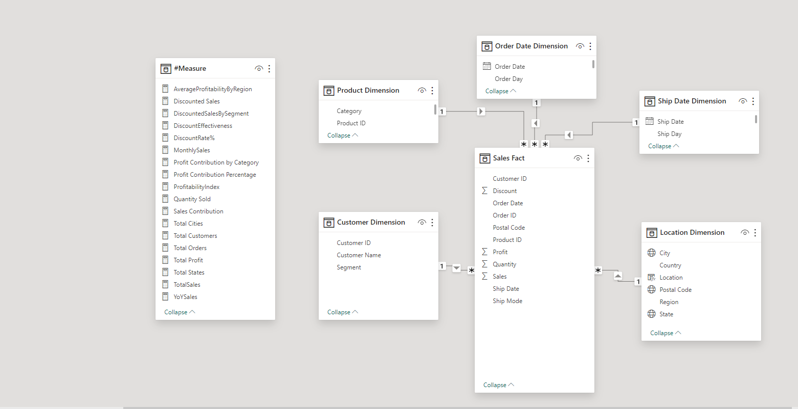

Fig 96: Data Model using Star Schema.

### **Selection of Key Performance Indicators (KPIs):**

Careful consideration was given to the KPIs in order to customise the BI solution to the unique requirements of the retail sector. The creation of metrics such as total sales, total profit, profit contribution by category, sales contribution by customers, discount rates, and others allowed for a thorough understanding of the state and performance of the retail industry.

### **Why Power-BI?**

For our retail dataset acquired from Kaggle, Power BI was the most popular Business Intelligence (BI) solution because of its flexible features and easy integration. The platform's intuitive design made it suitable for users with varying technical skills, guaranteeing broad acceptance within our heterogeneous team. Effective extraction and integration were made possible by the tool's flexibility with several data sources, which is essential when working with Kaggle datasets in a variety of formats. The strong data visualisation features of Power BI were essential in enabling us to develop engaging and eye-catching dashboards that successfully communicated the insights from the Kaggle-sourced data. Furthermore, Power BI's scalability played a crucial role in managing the diverse sizes of Kaggle datasets, guaranteeing peak performance despite variations in data quantities. Collaboration was further enhanced by Power BI's collaborative features, which allowed for real-time collaboration on reports and dashboards created using the Kaggle dataset. Finally, Power BI was the best option for providing value without sacrificing capability for our retail BI solution purchased from Kaggle because its cost-effectiveness fit our budgetary constraints.

# **3. Key Findings**

## **3.1 BI Dashboards**

### **Home Page Dashboard**

The dashboards created in this analysis are displayed below.

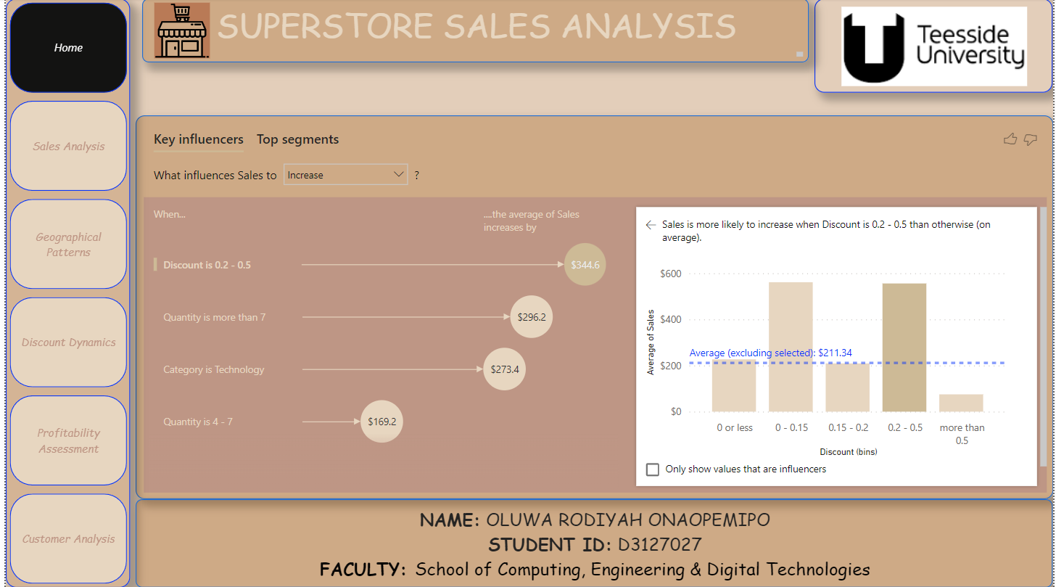

Fig 97: Home Page Dashboard.

This page is the home page of this superstore sales analysis dashboard. It gives a general introduction into what the analysis is about.

It contains a page navigation button that allows easy movement to other pages in the dashboard. A text box for the name of the project and one for author description was created.

It also includes a key influencer chart, With the use of the Key Influencers visual in Power BI, one can determine key variables in your data by examining the correlations between various variables and determining which of them is most closely linked to a specific result. The Key Influencers chart shows which features influences “Sales” to increase and decrease.

It shows that sales increases when:

* Discount is 0.2 - 0.5.
* Quantity is more than 7.
* Category is Technology.
* Quantity is 4 - 7.

It also shows that sales decreases when:

* Category is Office Supplies.
* Quantity is 1 or less.
* Discount is more than 0.5.
* Quantity is 1 – 2.

### **Sales Analysis Dashboard**

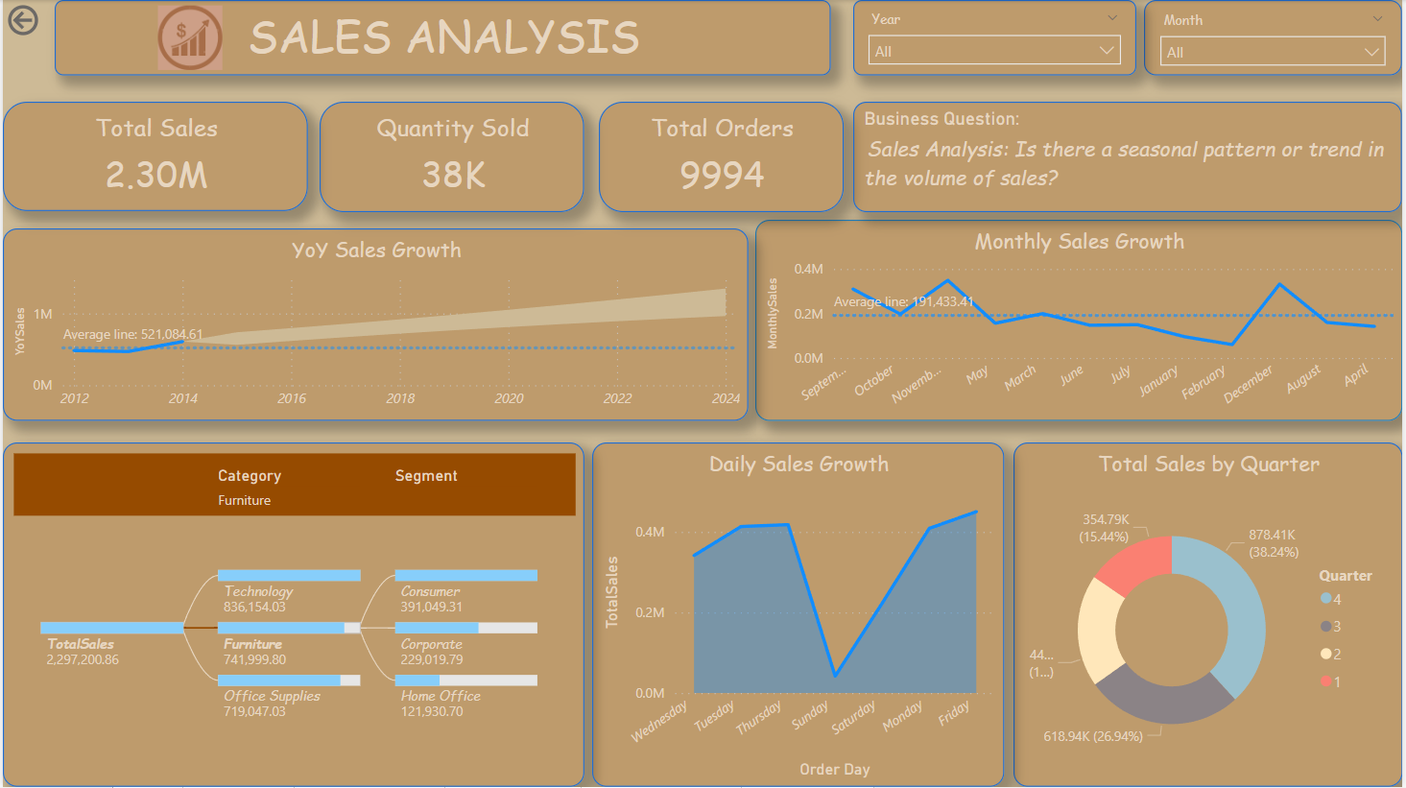

Fig 98: Sales Analysis Dashboard.

|  |  |  |
| --- | --- | --- |
| KPI & Measure | DAX Code | Description |
| Total Sales | TotalSales = SUM('Sales Fact'[Sales]) | This measure offers an overall aggregate of sales for all records. |
| Total Orders | Total Orders = COUNT('Sales Fact'[Order ID]) | This metric shows the total number of orders that have been recorded. |
| Quantity Sold | Quantity Sold = SUM('Sales Fact'[Quantity]) | This measure shows the total quantity of goods sold. |
| Year on Year Sales | YoYSales =  CALCULATE(  [TotalSales],  SAMEPERIODLASTYEAR('Order Date Dimension'[Order Date])  ) | Applying the total sales measure to the same period in the previous year through the SAMEPERIODLASTYEAR function on the 'Order Date Dimension' yields the year-over-year sales. |
| Monthly Sales | MonthlySales =  CALCULATE(  [TotalSales],  CROSSFILTER('Sales Fact'[Order Date], 'Order Date Dimension'[Order Date], BOTH)  ) | Undertaking a bidirectional cross-filter relationship between the 'Order Date' column in the 'Sales Fact' database and the 'Order Date' column in the 'Order Date Dimension' table, it computes the total sales. |

This Sales analysis dashboard gives an overview of the total sales generated in this record, total quantity sold and the total number of orders recorded, YoY sales growth, Monthly sales growth, daily sales growth, total sales generated per quarter, and total sales generated by each product category and customer segment. It also shows a forecast of YoY sales growth to be generated in coming years with a 95% confidence interval.

The key insights highligted are:

1. Total Sales generated from 2011 to 2014 was 2.30M
2. Total Quantity Sold within the period recorded was 38k
3. Total number of orders received was 9994
4. 2014 had a higher sales growth compared to the other years
5. Forecast on YoY sales shows that there’d be a constant increase in the sales generated yearly
6. November had the highest montly sales growth, while febuary had the lowest
7. Friday had the highest daily sales growth while Sunday had the lowest.
8. More sales were generated in the 4th Quarter of the year.
9. Technology is the product category that generated the highest total sales, while office supplies had the lowest.
10. Consumers were the customer segment with the highest sales while home office generated the lowest sales.

### **Geographical Pattern Dashboard**

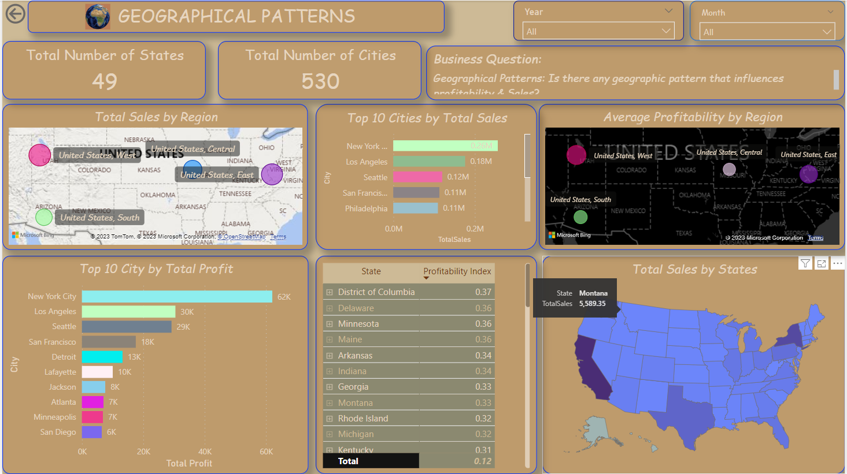

Fig 99: Geographical Pattern Dashboard.

|  |  |  |
| --- | --- | --- |
| KPI & Measures | DAX Code | Description |
| Total States | Total States = DISTINCTCOUNT('Location Dimension'[State]) | This measure calculated the total number of states in the record. |
| Total Cities | Total Cities = DISTINCTCOUNT('Location Dimension'[City]) | This measure calculated the total number of cities in the record |
| Average Profitability by Region | AverageProfitabilityByRegion =  DIVIDE(      SUM('Sales Fact'[Profit]),      CALCULATE(COUNTROWS('Sales Fact'), ALLEXCEPT('Location Dimension', 'Location Dimension'[Region]))  ) | The average profitability is determined by dividing the total profit by the number of rows, taking into account all regions inside the 'Location Dimension' with the exception of the context-relevant present region. |
| Total Profit | Total Profit = SUM('Sales Fact'[Profit]) | This metric shows the total earnings for all records combined. |
| Profitability Index | ProfitabilityIndex =  DIVIDE(      SUM('Sales Fact'[Profit]),      SUM('Sales Fact'[Sales])  ) | By dividing the total profit by the total sales, it determines the profitability index and yields a ratio that shows the proportion of profit in relation to sales. |

This Geographical Pattern dashboard gives an overview of the total number of states and cities this organisation operates within, it includes a map that shows the regions with the highest and lowest number of sales generated, bar charts that show the top 10 cities by total sales and total profit, a map that shows the average profitability generated by each region, a shape mp that shows the total sales by states and a matrix that shows the profitability index for each city,

The Key insights highligted are:

1. Total Number of states the organisation operates is 49
2. There is a total number of 530 cities.
3. The west generated the highest number of sales while the south generated the lowest
4. The west had the highest average profitability while the cemntral had the lowest.
5. New York city generated the highest number of sales and profit.
6. District of Columbia is the city with the highest profitability index.
7. California is the state with highest number of sales recorded.

### **Discount Dynamics Dashboard**

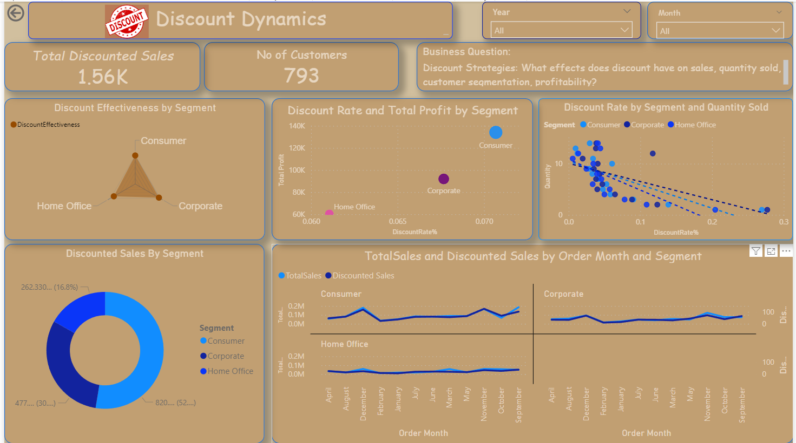

Fig 100: Discount Dynamic Dashboard.

|  |  |  |
| --- | --- | --- |
| KPI & Measures | DAX Code | Description |
| Total Discounted Sales | Discounted Sales = SUM(‘Sales Fact’[Discount]) | This metric shows the total amount of discounts applied to all records. |
| Total no of Customer | Total Customers = DISTINCTCOUNT(‘Customer Dimension’[Customer ID]) | This measure calculated the total number of customers in the record |
| Discount Rate | DiscountRate% = DIVIDE(SUM(‘Sales Fact’[Discount]), SUM(‘Sales Fact’[Sales]), 0) * 100 | By dividing the total amount of discounts by the total amount of sales and multiplying the result by 100, the discount rate percentage is computed. When the denominator is 0, the DIVIDE function replaces the result with zero to prevent division by zero problems. |
| Discount Effectiveness | DiscountEffectiveness = DIVIDE(SUM(‘Sales Fact’[Discount]),(‘#Measure’[TotalSales]), 0) | By dividing the total of all discounts by the total sales, it determines how effective discounts are. To address situations in which the total sales may be zero, the DIVIDE function is used, and zero is substituted for the result. |
| Discounted Sales by Segment | DiscountedSalesBySegment =  CALCULATE(      SUM(‘Sales Fact’[Discount]),      ALLEXCEPT(‘Customer Dimension’, ‘Customer Dimension’[Segment])  ) | Taking away all filters but the 'Segment' column in the 'Customer Dimension' table, it determines the total amount of discounts for every customer segment. |

This Discount Dynamics dashboard gives an overview of the total amount of discount recorded and the total no of customers the organisation has. It includes a radar chart that shows the discount effectiveness for each segement, scatter plots that show the discount rate by total profit and quantity sold for each segment, donut chart showing total discounted sales by segment and a multi-line chart showing the monthly total sales and discounted sales for each segment.

The key insights highligted are:

1. Total discounted sales recorded was 1.56k.
2. There is a total number of 793 Customers.
3. Consumer was the segment with the highest discount effectiveness
4. There’s a positive relationship between discount rate and total profit. i.e as discount rate increased total profit also increased.
5. There’s a negative relationship between discount rate and quantity sold. i.e as discount rate increased quantity sold decreased.
6. Consumer Segment is the segment with the highest discounted sales.
7. Consumer segment had a higher discounted sales which also led to them generating more monthly sales.

### **Profitability Assessment Dashboard**

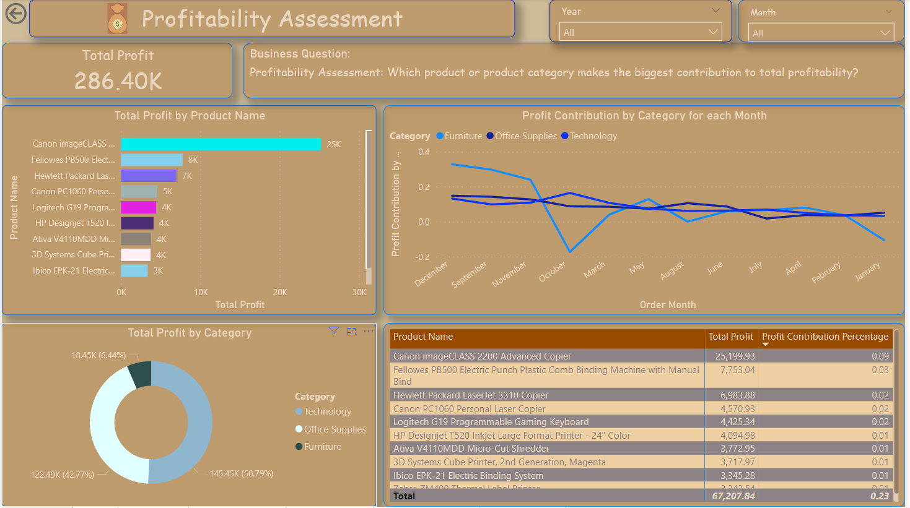

Fig 101: Profitability Assessment Dashboard.

|  |  |  |
| --- | --- | --- |
| KPI & Measures | DAX Code | Description |
| Total Profit | Total Profit = SUM('Sales Fact'[Profit]) | This measure offers an overall aggregate of profit for all records. |
| Profit Contribution by Category | Profit Contribution by Category = SUM('Sales Fact'[Profit]) / CALCULATE(SUM('Sales Fact'[Profit]), ALL('Order Date Dimension')) | The measure determines the profit contribution for every category by dividing the overall earnings for the chosen category by the total profits for all categories, considering all values in the 'Order Date Dimension'. |
| Profit Contribution Percentage | Profit Contribution Percentage = DIVIDE([Total Profit], CALCULATE([Total Profit], ALL('Product Dimension'))) | The percentage contribution of profit for each product is determined by dividing the overall profit for the chosen product by the total profit for all products, taking into account all values in the 'Product Dimension'. |

This Profitability Assessment dashboard gives an overview of the total amount of profit generated. It includes a bar chart showing the total profit generated by each segment, a donut chart ahowing the product category that generated the highest profit,a matrix showing the profit and profit contribution percentahe generated for each product, a line chart showing the profit contribution by category for each month.

The key insights highligted are:

1. Total profit generated was 286.40k.
2. Canon Image Class 2200 Advanced Copier was the product that generated the most profit.
3. Technology was the product category that generated the highest profit.
4. Canon Image Class 2200 Advanced Copier was the product that had the highest profit and profit contribution by percentage .

### **Customer Analysis Dashboard**

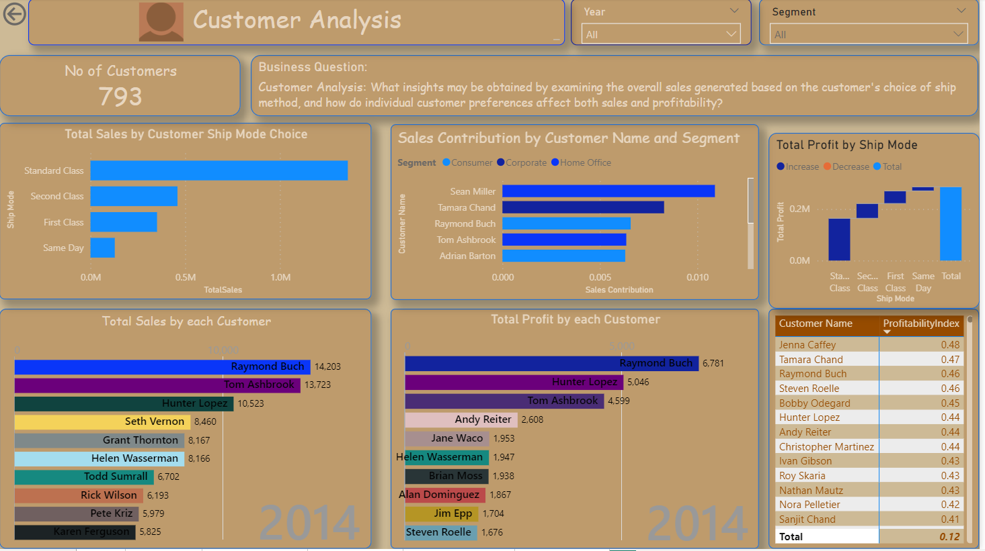

Fig 102: Customer Analysis Dashboard.

|  |  |  |
| --- | --- | --- |
| Total Customers | Total Customers = DISTINCTCOUNT('Customer Dimension'[Customer ID]) | This measure calculated the total number of customers in the record |
| Sales Contribution by Customers | Sales Contribution = '#Measure'[TotalSales] / CALCULATE(SUM('Sales Fact'[Sales]), ALLEXCEPT('Sales Fact', 'Customer Dimension'[Customer ID])) | It calculates the contribution of sales for each customer by dividing the total sales for the selected customer by the total sales across all customers, considering all values in the 'Customer Dimension' except the 'Customer ID'. |

This Customer Analysis dashboard gives an overview of the total number of customers using a card visual. It includes a clustered bar chart showing the total sales by consumers ship mode choices, a stacked bar chart showing the sales contribution by customer name and segment, a waterfall chart showing the total profit generated from each ship mode, animated bar chart race showing the total sales and profit generated from each customers. A matrix showing the profitability index of each customer.

The key insights highligted are:

1. Total No of Customers is 793.
2. Standard Class is the ship mode that generated the highest sales.
3. Standard Class is the ship mode that generated the highest profit.
4. Raymond Buch is the customer that generated the highest sales and profit.
5. Jenna Caffey was the customer with the highest profitability index.
6. Sean Miller a customer from the consumer segment had the highest sales contribution.

# **4. Challenges and Limitations**

There are several obstacles and restrictions associated with putting a Business Intelligence (BI) system into place, especially when it comes to a retail dataset that was gathered via Kaggle. These factors are critical to comprehend since they influence the BI solution's efficacy and reach.

## **Challenges**

1. **Complexity of Retail Dynamics:** Establishing reliable Key Performance Indicators (KPIs) becomes more difficult due to the complex nature of retail, which is characterised by constantly changing consumer behaviour and industry trends.
2. **Tool Learning Curve:** Although Power BI is easy to use, there is a learning curve involved in becoming proficient with its more complex features. It took time to become proficient in using the gadget to its full potential.

## **Limitations**

1. **Complexity of Retail Dynamics:** Despite their sophistication, BI systems may not be able to fully capture and predict the complex dynamics of the retail sector, necessitating ongoing adaption.
2. **Tool Learning Curve:** Insufficient experience could prevent one from fully utilising Power BI, which could result in underusing some of its more sophisticated features.

# **5. Conclusions and Recommendation**

## **5.1 Conclusion**

In conclusion, the Power BI Business Intelligence analysis performed on the given retail dataset has produced insightful results in several areas. A thorough summary of sales trends was given by the Sales Analysis Dashboard, which also highlighted important patterns in monthly, daily, and quarterly sales as well as a noteworthy growth in 2014. The organization's operational footprint is illuminated by geographic patterns, which show notable differences in sales and profitability between locations and cities. The Discount Dynamics Dashboard emphasised the necessity for focused discount tactics by highlighting the complex link between discounts, sales, and client segments. Strategic decisions were guided by the Profitability Assessment Dashboard, which identified high-performing items and categories. Finally, a thorough examination of client behaviours, preferred ship modes, and individual contributions to sales and profitability was provided by the client Analysis Dashboard.

## **5.2 Recommendation**

**Sales Strategies:**

Pay close attention to maximising sales during the days and months that the Sales Analysis Dashboard indicates as peak sales.

Examine ways to leverage the trend and increase sales even more in the fourth quarter.

**Geographical Expansion:**

To improve overall geographic performance, consider reinforcing methods in areas with weaker sales, like the south.

Take advantage of the enormous earning possibilities seen in places like New York and investigate prospects in the District of Columbia.

**Discount Optimisation:**

To preserve efficacy, keep examining and improving discount tactics, particularly in the consumer sector.

Keep an eye on how discounts affect profit and amount sold, then modify rates appropriately.

**Product and Category Focus:**

Keep advertising technology-related goods, with special emphasis on highly profitable models such as the Canon Image Class 2200 Advanced Copier.

Examine possibilities in other product areas to increase profitability and diversify.

**Customer-Centric Approach:**

Adapt marketing and sales initiatives to consumers' ship mode choices, particularly those belonging to the consumer sector.

Expand upon the achievements of highly contributing clients like Jenna Caffey and Raymond Buch to improve overall client engagement.

These recommendations, which are the outcome of thorough BI insights, are meant to direct strategic decision-making, improve operational effectiveness, and eventually accelerate the company's long-term growth and profitability.

# **5. References**

Dataset from Kaggle: <https://www.kaggle.com/datasets/ishanshrivastava28/superstore-sales>